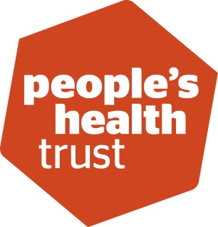
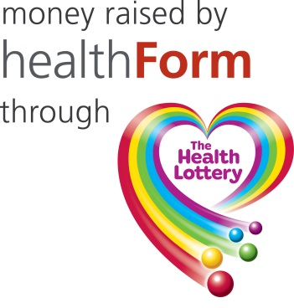

Looking for local funding?
Please complete this checklist to see if your organisation is eligible to apply to the Active Communities Programme:
Question | Response (delete as appropriate)
1. Are you a not-for-profit organisation or group? | YES OR NO
2. Has your organisation or group been constituted for at least three months? | YES OR NO
3. Is your total yearly income less than £350,000, or an average of £350,000 over two years? | YES OR NO
4. If you are a new organisation is your total income to-date or your projected income for the current year less than £350,000? | YES OR NO
5. Do you have unrestricted reserves (savings) of less than six months of your yearly expenditure, after deducting the amount you are thinking of requesting from the Trust? | YES OR NO

If you cannot answer YES to ALL the questions above unfortunately you are not eligible to apply to the Active Communities Programme on this occasion.
If you have answered YES to ALL the above questions; see below

We are looking for locally-led ideas that can bring local people together to do something positive.

Now tell us what you want to do. Tell us about your idea: please cover the following four points:

- A very brief summary of what you want to do in 140 words.

- How the idea you are proposing came about and how local people will be in control of the idea going forward in 200 words.

- How the idea will bring local people together regularly in 150 words

- How many people will attend very regularly and how often these people will attend in 10 words.

