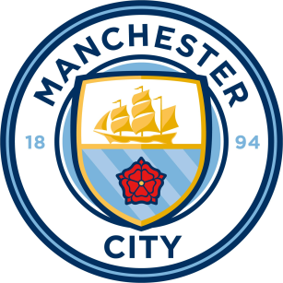
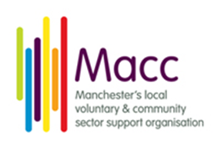

Does your Organisation or Community Group need a new, exciting and fresh way of raising unlimited funds?
Following on from a previously successful information event Fabulous Fan Fayre, Macc are inviting local VCSE groups to come along to the Etihad Stadium to find how you can become part of a unique partnership.
Date: Wednesday 8th August 2018
Time: 12pm-1:30pm
Address: Etihad Stadium, Rowsley Street , Manchester
The F3 ‘Not for Profit Programme’ at Manchester City Football Club are looking to work with local not for profit organisations and their volunteers to deliver stadium catering to the thousands of fans at matches and events in a dedicated ‘Not for Profit’ charity kiosk. There are two types of kiosk available (beer and food) with additional incentives offered to increase the amount of funding received.
A percentage of the profits generated by each kiosk is paid directly to the group and last football and concert season over £150,000 has jointly been paid out to the not for profit organisations already involved.
What are the benefits to local community groups?
• Help raise unrestricted additional income in a unique way
• Advertise your charity on the screens in your own dedicated kiosk – raising profile and awareness to a wide audience
• Opportunity to work together in a team with colleagues in a completely new way
• All volunteers will receive training and develop new skills
Take a look at some pictures………
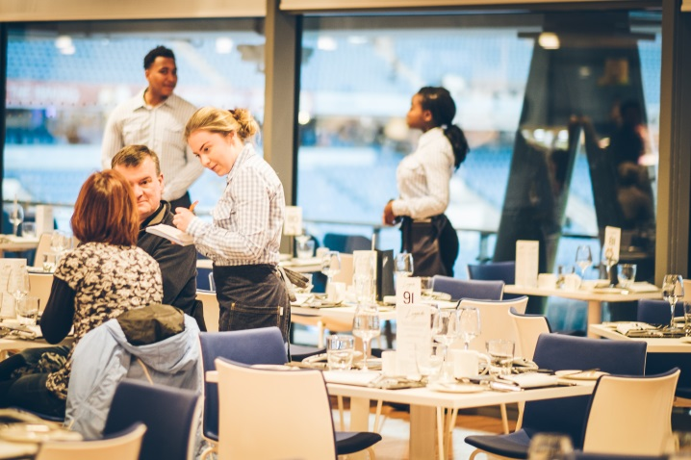

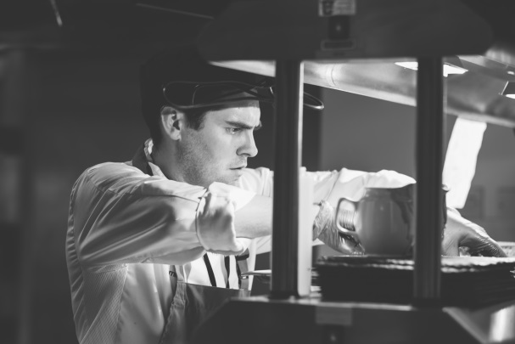
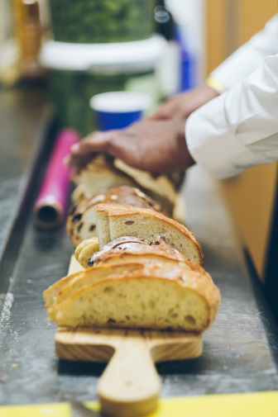
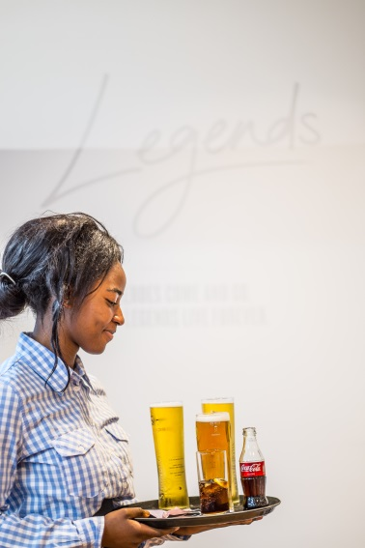

What does this initiative need?
• Between 6 and 8 volunteers are required to staff a kiosk at any given time which includes all match days, sporting events and concerts throughout the whole year.
• A volunteer shift lasts between 4.5 and 5 hours.
• Not for profit organisations are expected to commit to running a kiosk week in week out.

This event is a chance for you to find out more about how the scheme works and ask any questions you may have.
For further information contact Cheryl McAlister
Tel: 0161 834 9823
Email: cheryl@macc.org.uk

