Measles Prevention Toolkit - Information is aimed at parents and those who care for children and young people – 15 June 2023
Additional instructions
Please ensure that all images posted on social media make use of the 'alt text' function and duplicate any words that appear in a graphic, so the same information is accessible to those using screen readers.
You should also describe any imagery that appears within this description. Please also ensure that key information is communicated in the post text, rather than relying on a visual asset. You can find further guidance and how to do this for different platforms below and for further advice on writing image descriptions, see below:
RNIB - Making you social media accessible
Twitter
Facebook
Theme | Message | Graphic/link
Measles – awareness of the symptoms – stay up to date with your MMR vaccinations | Twitter/Facebook  ⌚ 15 mins with someone who had measles is enough time for the virus to be passed on.  Measles can have serious and sometimes fatal consequences, so make sure you’re up to date with #MMR vaccinations, and ask your GP about catch up jabs if you need. | 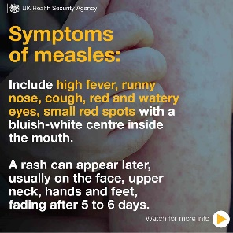  Social media graphic attached to email
Advice to parents to vaccinate their child against measles, mumps and rubella. | Twitter/Facebook  Two doses of the #MMR vaccine offer protection for life against #measles, #mumps and #rubella.  Are you and your loved ones protected? If you’re not sure, contact your GP about getting catch up  Jabs.  More info: nhs.uk/MMR | 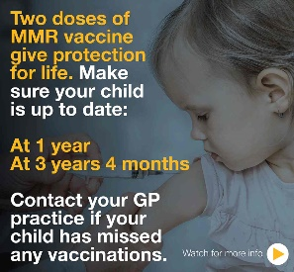  Social media graphic attached to email  URL Link:  nhs.uk/MMR
Check if your child’s measles vaccinations are up to date before travelling abroad this summer. | Twitter/Facebook  If you’re planning to travel abroad during the school holidays, make sure to check your child is up to date with their vaccinations, including the #MMR vaccine.  Contact your GP to book any catch up jabs before you travel ✈🚢🚉 | 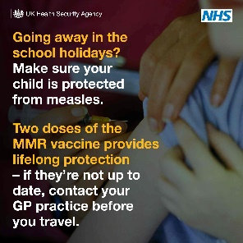  Social media graphic attached to email

