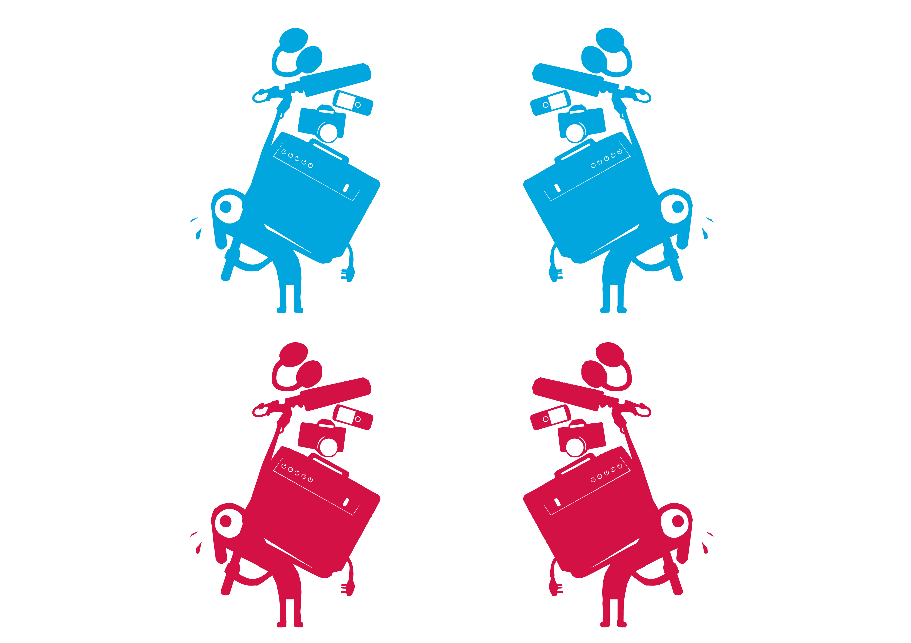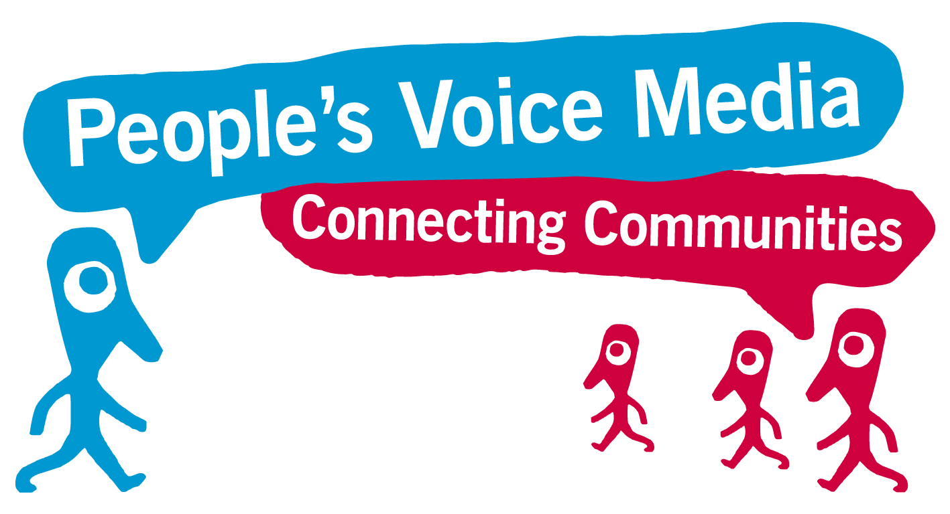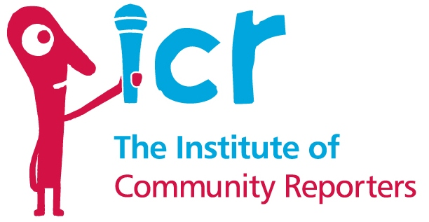

**Want to find out more?**

If you would like to find out more about becoming a   
Community Reporter and being a part of this project,   
then join us for a fully accessible Briefing Event on:

**Time & Date:** 10:30 – 12:00pm, Friday 12th May 2017

**Venue:** The Woodlands Suite, The Abraham Moss   
Centre, Crescent Road, Crumpsall, Manchester,   
M8 5UF. Please call 0161 234 3950 to confirm attendance.

You’ll be able to see examples of Community

Reporter work and ask our team any   
questions!

**The Institute of Community Reporters are currently working in communities around Greater Manchester to gather people’s experiences and views on public services. We are training up groups of people as Community Reporters to use pocket devices and technology to record these experiences as video or audio stories, and share them with others online.**

Working with Breakthrough UK, we will be delivering a 2-Day Community Reporter programme in Manchester for disabled people. As part of the training, people will learn how to use the basic video and audio recording functions on their phones and tablets, how to tell and gather stories, and how to responsibly share stories online.

The stories gathered will feed into the on-going public service reform across Greater Manchester. Participants are also be able to join our growing UK and European-wide network of Community Reporters and continue to   
share their stories after the programme. So we need **You** to   
get involved!

**Have Your Say!**

**www.communityreporter.net**