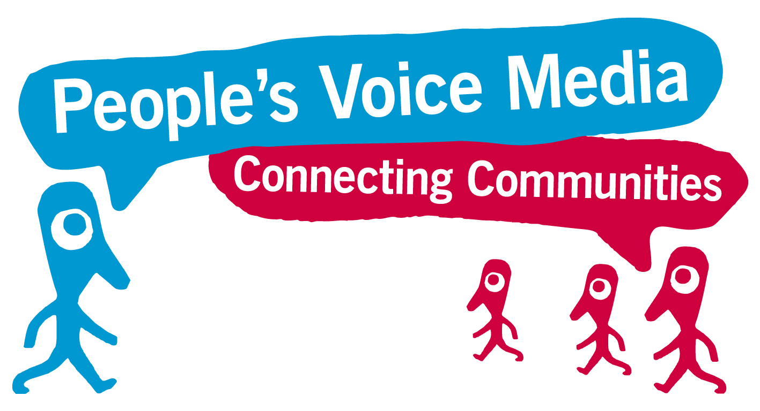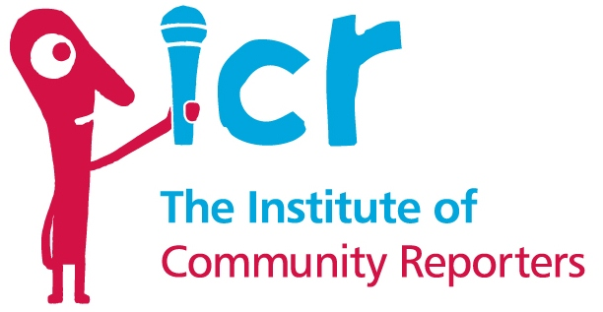

**Do you want to be a Community Reporter?**

**Community Reporters talk to people about what is important to them in their lives.**

**They use their phones and tablets to record people’s stories.**

**Then they put people’s stories and videos on the internet.**

We need **You** to get involved!

**You can come along to a short meeting meet the trainer and see videos that community reporters have done.**

**Then you can decide whether you would like to do**

**The 2 day training to be a Community Reporter**

**Want to find out more?**

**Come and meet us on**

**Friday 12th May 2017**

**10:30am to 12 noon**

**At: The Woodlands Suite**

**The Abraham Moss Centre**

**Crescent Road, Crumpsall**

**Manchester M8 5UF**

Please call Elaine to say you are coming

on 0161 234 3950

**Have Your Say!**

**www.communityreporter.net**