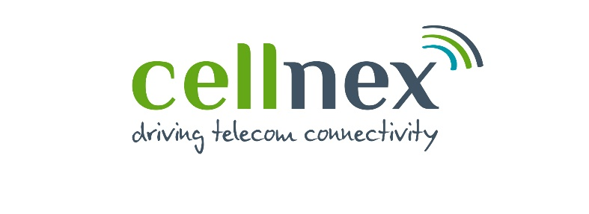
Cellnex Digital Inclusion Fund

We are delighted to announce that the Cellnex Digital Inclusion Fund is now open for applications from Community Groups in Greater Manchester.

The Cellnex Digital Inclusion Fund is offering awards of up to £5,000.

We will close for applications at midday on Friday 18th August 2023.

Fund Criteria
The Cellnex Digital Inclusion Fund aims to support community projects tackling digital exclusion across Greater Manchester. The Fund will focus on three main themes that align with the Greater Manchester Digital Inclusion Strategy as follows:
- Empowering communities and places
- Increasing confidence, skills and motivation
- Affordability, accessibility and connectivity.

Who can apply?
The Cellnex Digital Inclusion Fund aims to encourage and support grassroots community organisations. This means small, community-based and locally controlled groups that manage themselves.

Applicants must have an annual income of less than £150,000.

How much can you apply for?
The maximum award request that will be considered is £5,000.

What can you apply for?
Local groups understand how they can best work in their communities to promote digital inclusion. We don’t want to limit the type of request you can make, let us know what you want to do and what positive things your activity will provide for people in your community, as long as it meets one of the 3 themes above.
Some examples of digital inclusion projects include:
- Sessions aimed at helping people in your community to develop digital skills
- provide digital-based training to young people
- improve online access for jobseekers
- refurbished computers for the local community
- access to technology to tackle social isolation
- making community information accessible to all
- online support service for the community.
To learn more about digital inclusion, what the issues are in Greater Manchester and further information about this topic, please see the Greater Manchester Digital Inclusion Strategy,

Is there anything you can’t apply for?
Unfortunately, there are a few things that can’t be funded, such as activities that have already taken place or been paid for, contributions to major appeals, activities promoting political or religious beliefs and activity which should be provided by statutory services.

If you’re not sure if we could consider your application for funding, please contact a member of the Forever Manchester Communities Team, email awards@forevermanchester.com and we’ll be happy to help.

Supporting Documents
For help and guidance on your groups’ supporting documents and to see what we require to be submitted alongside your application, please refer to our guidance which you can find here: Supporting Information.

Deadline for Applications
We will close for applications at midday on Friday 18th August 2023. Any applications received after this time will not be considered.

How long will a decision take?
We aim to let you know the outcome of your application in late October 2023. Please do not plan to start any activity until after you hear if your application has been successful.

Our Frequently Asked Questions (FAQs) provide further information on our funding programmes. We encourage you to have a look if you would like to know a bit more about who can apply and what the application process involves.
If you have any questions or have trouble completing your application, please contact us at awards@forevermanchester.com or phone 0161 214 0940.

About Cellnex
Cellnex UK is part of Cellnex Telecom, Europe's largest independent telecoms infrastructure provider. With the wireless infrastructure foundation that we deliver across rural and urban areas, Cellnex UK connects everyone, everywhere.

Our commitment to connectivity extends beyond infrastructure; we are dedicated to closing the digital divide in the UK, helping people stay connected by promoting digital skills and providing access to digital devices and services to the communities that need it most.

With one of our biggest UK offices located in Manchester, we are committed to helping the region thrive. Digital inclusion is key to social and economic prosperity, and we are proud to be working with Forever Manchester to ensure that the communities in areas where we workhave the tools they need for an increasingly digitised society.

Find out more: www.cellnex.co.uk

