Cost of Living Toolkit – 5 December 2023
Additional instructions
Please ensure that all images posted on social media make use of the 'alt text' function and duplicate any words that appear in a graphic, so the same information is accessible to those using screen readers.
You should also describe any imagery that appears within this description. Please also ensure that key information is communicated in the post text, rather than relying on a visual asset. You can find further guidance and how to do this for different platforms below and for further advice on writing image descriptions, see below:
RNIB - Making you social media accessible
Twitter
Facebook
Theme | Message | Graphic/link
For support and advice with the cost of living call Manchester’s free cost of living advice line. | Twitter/Facebook  Poverty can affect anyone from any background, and nobody should struggle to feed themselves or pay bills.  You’re not alone, 📞call Manchester’s Cost of Living advice line for support.  💻manchester.gov.uk/coladvice  #MakingManchesterFairer | 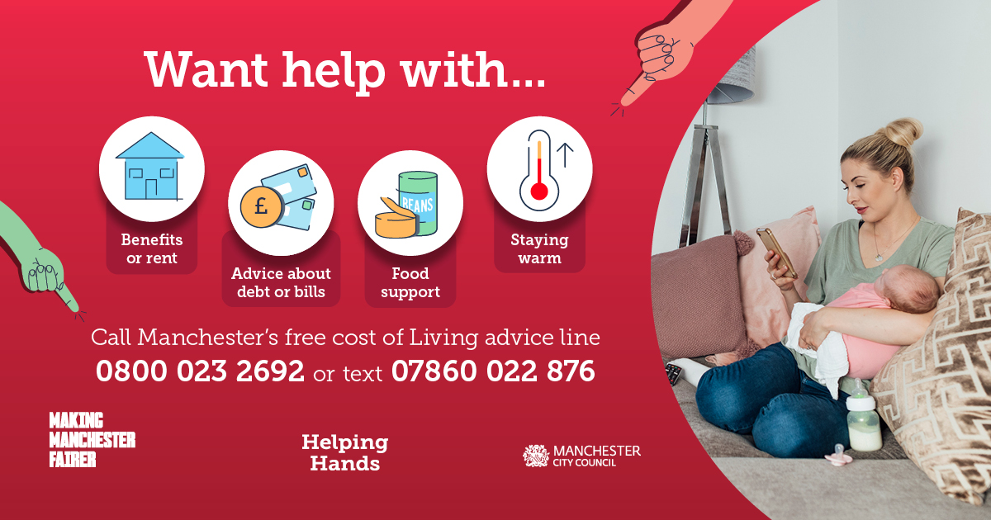  Social media asset  URL  manchester.gov.uk/coladvice
Find your Warm Welcome Space in Manchester | Facebook  No one should struggle to stay warm this winter. Manchester has warm welcoming spaces for everyone to go for a brew, a chat and a warm through.  Find yours:  warmwelcome.uk manchester.gov.uk/helpinghands  Call 0800 023 2692 Text 07860 022 876  #MakingManchesterFairer | 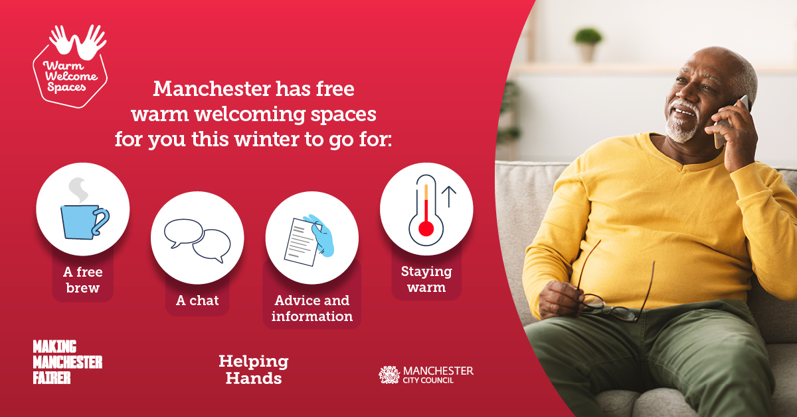  Social media asset  URL  warmwelcome.uk  manchester.gov.uk/helpinghands
Find your Warm Welcome Space in Manchester | X/Twitter  No one should struggle to stay warm this winter.  Manchester has warm welcoming spaces for everyone to go for a brew, a chat and a warm through.  Find yours:  warmwelcome.uk manchester.gov.uk/helpinghands  Call 0800 023 2692 Text 07860 022 876  #MakingManchesterFairer | 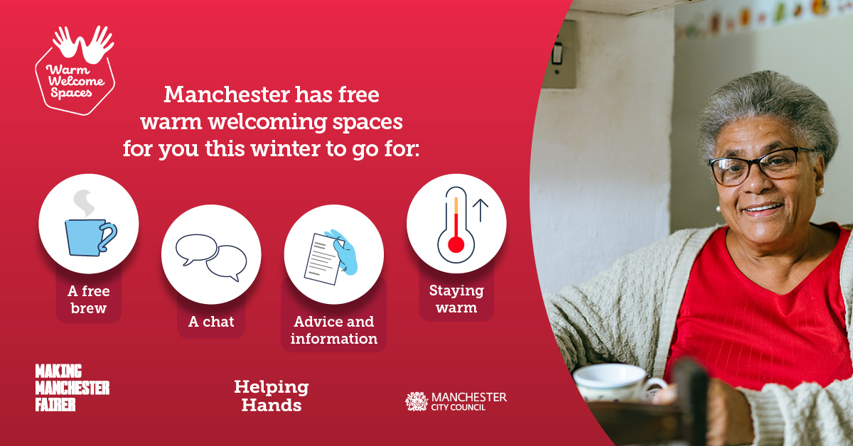  Social media asset  URL  warmwelcome.uk  manchester.gov.uk/helpinghands
Manchester’s libraries are warm welcome spaces for everyone this winter. | X/Twitter/Facebook  Winter is a challenging time for households, but your local library is a warm space that welcomes everyone.  So, call in to have a brew, a chat and get online.  Stay as long as you want.  manchester.gov.uk/libraries  Call 0800 023 2692 text 07860 022 876  #MakingManchesterFairer | 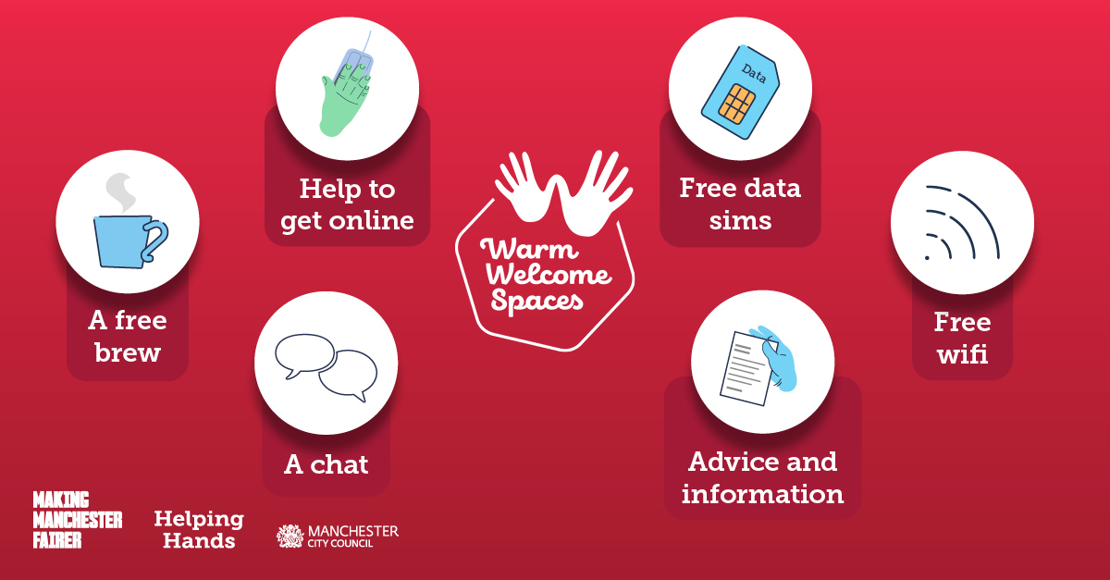  Social media asset  URL  manchester.gov.uk/libraries

