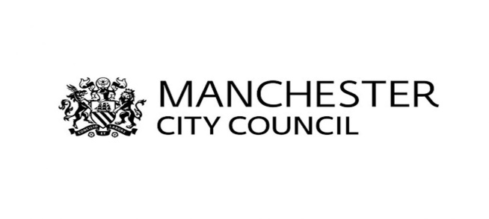
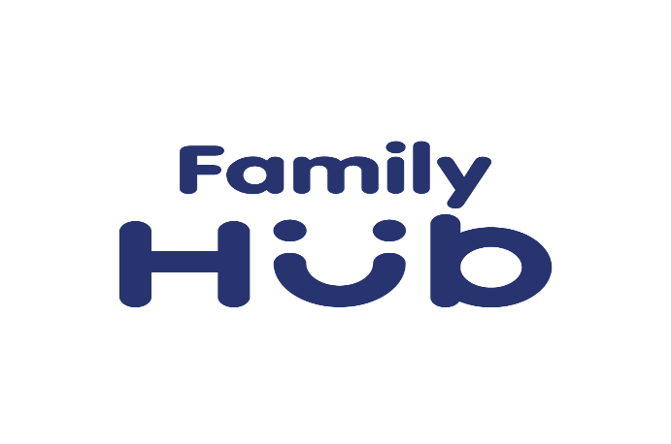

FAMILY HUBS FUNDING INFORMATION
Aims & Priorities
The purpose of the grant schemes is to improve outcomes for children and families through:

- Contributing to and/or increasing the uptake of services which could include; strengthening parent and child relationships, increasing/improving the offer of parenting support or meeting the wider family hub criteria (link below highlights wider criteria) Annex E - Family Hub Model Framework (publishing.service.gov.uk)
- Community engagement, targeting those communities who have yet to engage and/or who are at risk of poorer outcomes e.g. experiencing racial inequalities (CERI), high levels of deprivation
- Co-design/production of services and activities that meet local need

Bids that propose the delivery of services that look to strengthen parent and child relationships or offer parenting support should look to demonstrate how families will be supported to achieve:

- Improvements in their relationship with their child
- Improvements in their mental health
- Improved engagement with other services
- Increased involvement in their child’s development
- Increased self-confidence
- Improved understanding of their child’s needs

Bids that support community engagement, which will lead to an increase in engagement and take up of services across the Family Hub sites, should demonstrate how they will increase engagement with:

- Communities that have yet to engage
- Parents and Carers with additional vulnerabilities who are at risk of poorer outcomes
- Fathers and co-parents
- Families experiencing SEND
- Communities experiencing racial inequalities, deprivation and isolation

Who can apply?

Applications from voluntary, community and faith sector organisations only

Organisations must be based in Manchester and bids must evidence how they would work with Manchester residents in either Longsight, Sharston/Woodhouse Park (Wythenshawe) or Cheetham/Crumpsall (locations of the Family Hubs)

Applications are welcomed from groups working together in a partnership
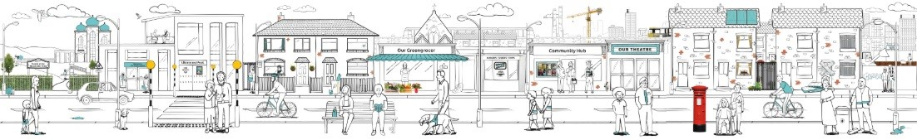

Grant Amounts
The following grants will be available for application:

Microgrants of up to £5,000

Small grants of up to £10,000

Application Process
Please read through the Family Hub Funding Prospectus carefully before considering whether to make an application. If your organisation has any trouble submitting the application online then please contact us as soon as possible at familyhubprogramme@manchester.gov.uk.

Provider Engagement
Drop-in sessions will be held which will provide the opportunity for interested parties to seek further information. These sessions will be held on the following dates.
- Wednesday 6th September between 9.30 – 11.30am at Longsight Hub
- Wednesday 6th September between 12.30 – 2.30pm at Cheetham Hub
- Monday 11th September between 1 – 3pm (virtual session)
- Thursday 14th September between 1 – 3pm at the Sharston Hub
If you are interested in attending any of the above sessions, please register your interest by emailing familyhubprogramme@manchester.gov.uk to inform of your interest. Further information will be provided upon registration.

Key Dates

Applications live: 29th of August 2023

Closing date: 4pm on the 6th of October 2023
- Applicants will be notified of decision by the 27th of October 2023

