Targeted Lung Health Check Programme
VCSE Briefing Note for Wythenshawe – December 2023

Local information
The Targeted Lung Health Check programme moves to parts of Wythenshawe from January 2024. It will begin by offering Lung Health Checks to patients who are smokers aged 55-74 based at three GP practices in Wythenshawe in January and February. Then from April will be available to patients who are smokers aged 55-74 across other parts of Wythenshawe, Northenden, and Brooklands.
FAQs about the Targeted Lung Health Check
Q. What is the aim of the Targeted Lung Health Check programme?
A. The aim of the programme is to detect lung cancer and disease early so that people can be treated sooner and more effectively – saving more lives. Lung cancer often has no symptoms in the earlier stages which can result in it not being found until the later stages when outcomes are less favourable.
Q. What is a Targeted Lung Health Check?
A. The lung health check takes part in two stages. The first is an appointment with a specially trained nurse to assess your risk level. If you are found to be at high risk of having lung cancer you will be eligible for a low dose CT scan so we can capture an image of your lungs and identify if there are any issues which need further investigation or treatment.
Q. Where will lung health checks take place?
A. The lung health check appointment and CT scan will take place in a mobile unit. The mobile units will be parked in community venues or supermarket car parks which have good transport links for ease of access.
Q. Who is eligible?
A. People aged 55 to 74 years old who are current or former smokers are eligible to take participate in the programme
Q. How will people be invited to the programme?
A. People will be invited to the programme based on the GP practice where they are registered. Everybody in the age range will be invited but only current or former smokers will be eligible for an appointment.
Q. I’m not eligible for the programme but concerned about my health, what should I do?
A. This is a targeted screening programme and people between 55 – 74 and have smoked more than 100 cigarettes in their lifetime are eligible. If you are worried about any of the below symptoms, please see your GP as soon as possible:
  - A persistent cough or change in your normal cough
  - Coughing up blood
  - Being short of breath
  - Unexplained tiredness or weight loss
  - An ache or pain when breathing or coughing
  - Appetite loss

Q. How can VCSE organisations support this programme of work in their local community?
A. As this is a new service, many patients may not be aware of its benefits. Catching lung cancer early can make all the difference and this programme has demonstrated that it is effective at diagnosing lung cancers at a much earlier stage.
Sharing this information and the displaying the below assets in community locations or on social media will help spread the message about the programme.
Funding is also available through the Greater Manchester Cancer Alliance for community engagement events in partnership with the Roy Castle Lung Cancer Foundation.
If you would like further information about the programme or have ideas about how to make the most of this opportunity for your local population, please get in touch with Oliver Butterworth – TLHC Project Manager (oliver.butterworth2@nhs.net)
Image of the TLHC Truck
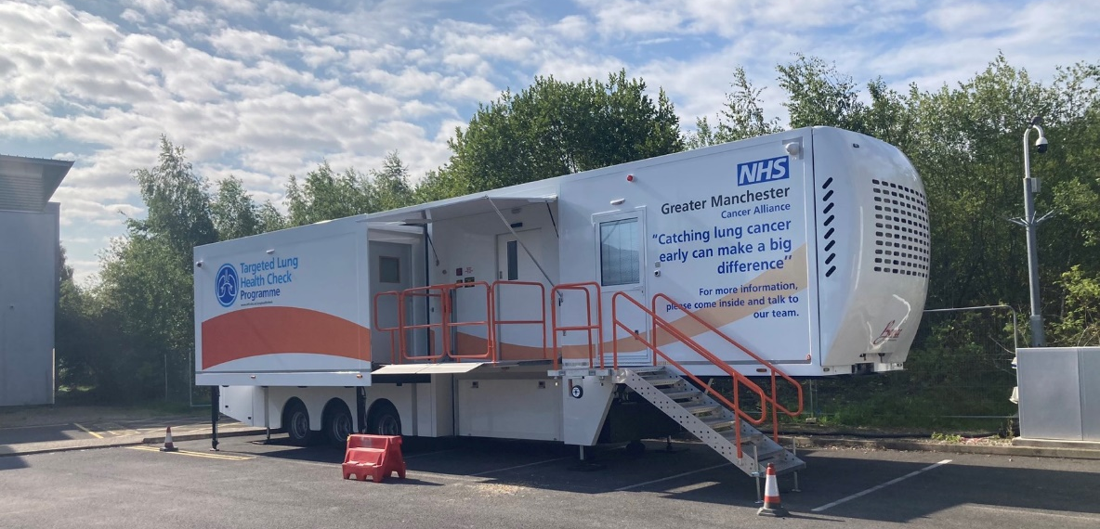

Community Engagement Events
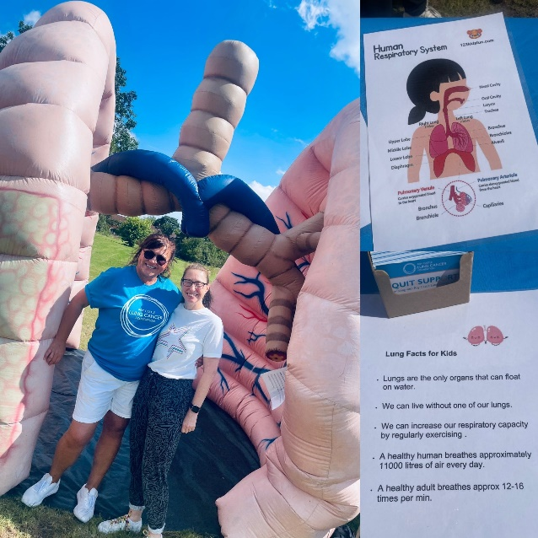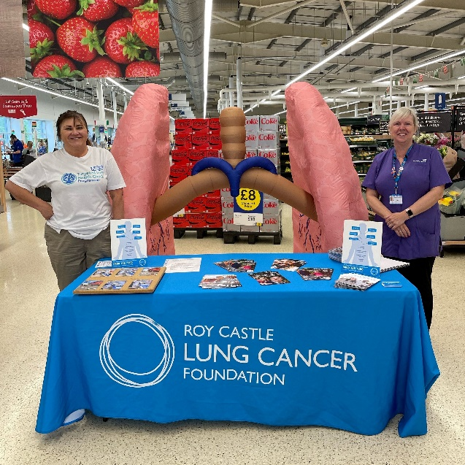
Posters
To display in community centres, libraries local businesses (either print out or contact Ali Barbuti, Communications Manager at Greater Manchester Cancer Alliance for hard copies a.barbuti@nhs.net).
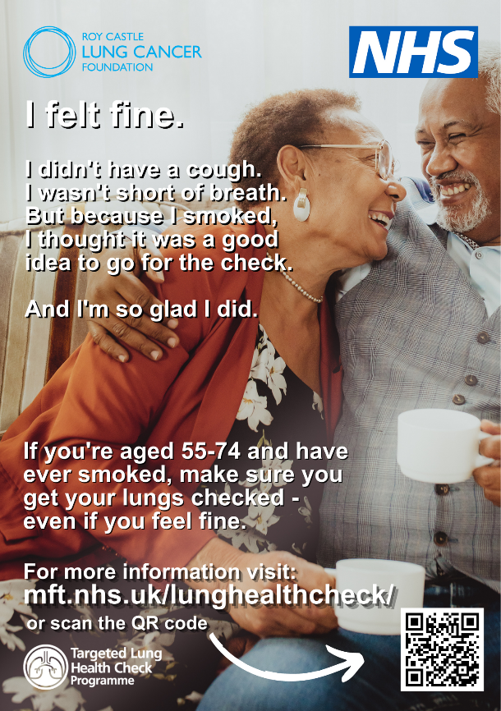 | - 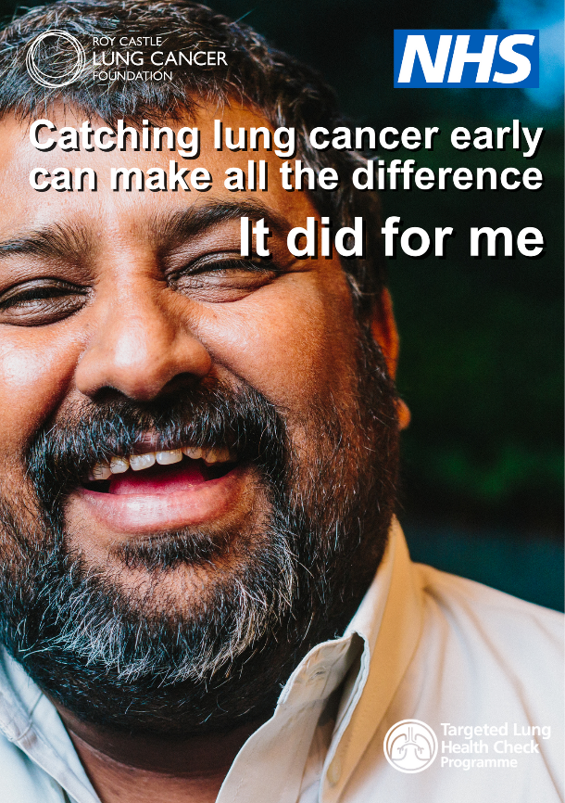
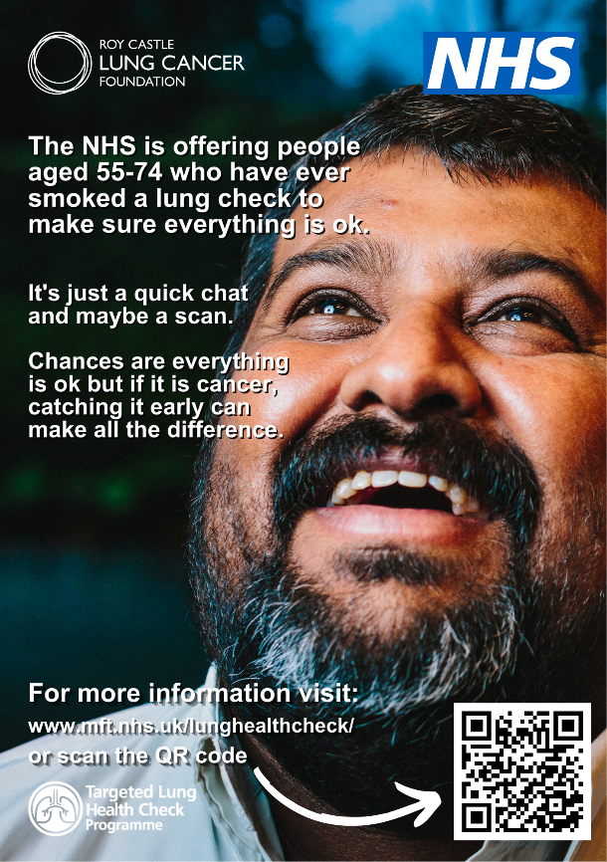 | 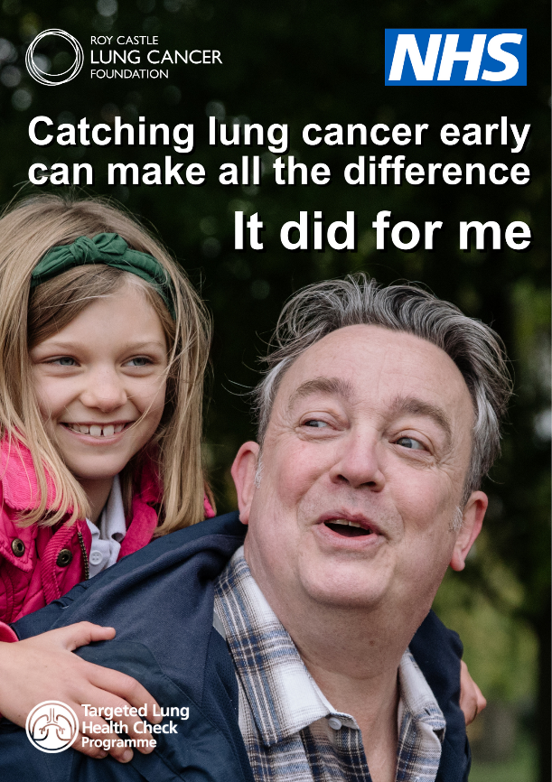

Social Media Assets
Please use the following copy with one of the images below on your social media channels.
Before the unit arrives late December/early January
FACEBOOK/WHATS APP:
Before April 2024
Catching lung cancer early can make all the difference.
The NHS will soon be offering free lung health checks in #Wythenshawe for anyone who’s ever smoked and is aged from 55-74 years This checks help to identify lung cancers at an early stage before you may have symptoms.
Look out for an invitation letter and additional information in the post. If you have already received your invitation but missed your appointment, please contact the bookings team on 0161 529 0900.
For more information, please visit: mft.nhs.uk/lunghealthcheck
#GMLungHealthCheck
After April 2024
Catching lung cancer early can make all the difference.
The NHS is offering free lung health checks in #Wythenshawe for anyone who’s ever smoked and is aged from 55-74 years This check helps to identify lung cancers at an early stage before you may have symptoms.
Look out for an invitation letter and additional information in the post. If you have already received your invitation but missed your appointment, please contact the bookings team on 0161 529 0900.
For more information, please visit: mft.nhs.uk/lunghealthcheck
#GMLungHealthCheck
TWITTER / X:
BEFORE APRIL 2024:
The NHS will be offering free lung health checks in #Wythenshawe for anyone who’s ever smoked aged 55-74 years. The check helps to find lung cancers at an early stage before you may have symptoms.
Look out for an invite in the post.
See mft.nhs.uk/lunghealthcheck
#GMLungHealthCheck

AFTER APRIL 2024:
The NHS is offering free lung health checks in #Wythenshawe for anyone who’s ever smoked aged 55-74 years. The check helps to find lung cancers at an early stage before you may have symptoms.
Look out for an invite in the post.
See mft.nhs.uk/lunghealthcheck
#GMLungHealthCheck

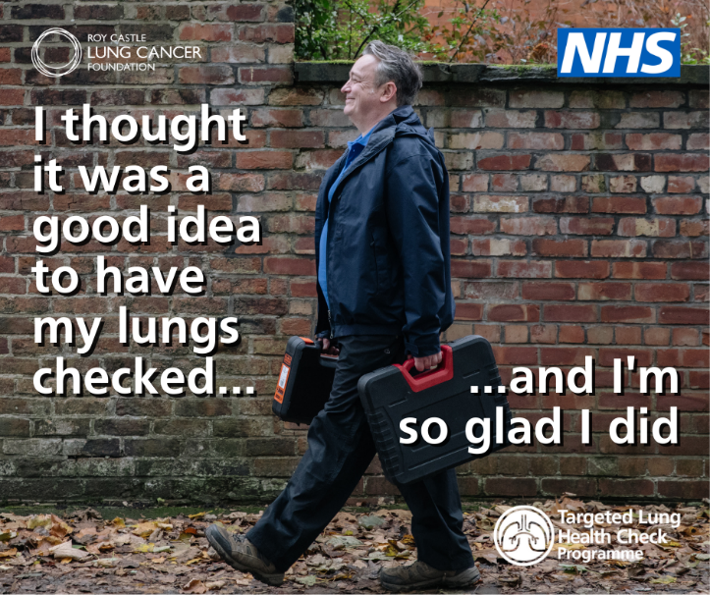 | 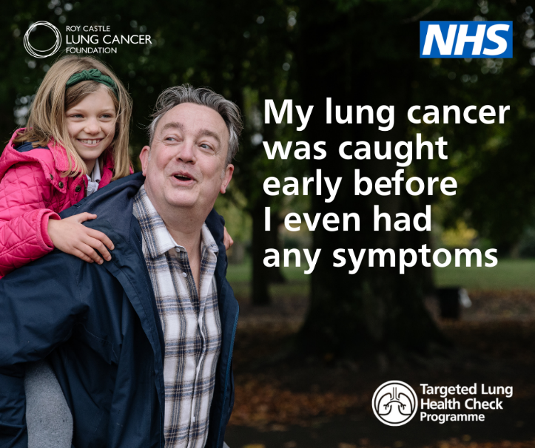
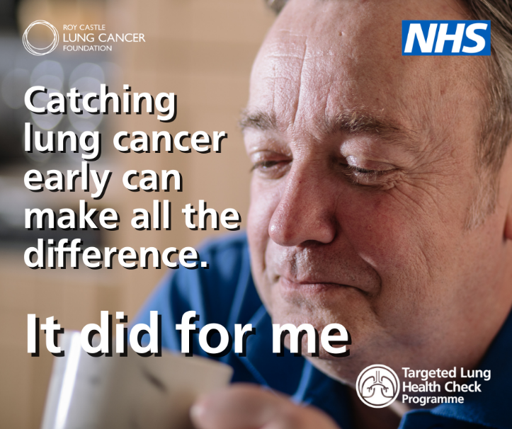 | 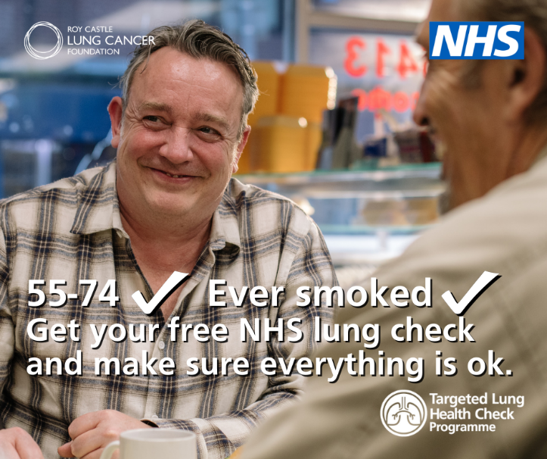
Short news story for websites
Car park lung health checks launched in drive to save more lives in Wythenshawe
Past and current smokers in parts of Wythenshawe aged between 55–74 years old are being invited to have an NHS Lung Health Check.
The new checks are the latest phase of the Greater Manchester Targeted Lung Health Check Programme – a drive to help improve earlier diagnosis of lung cancer and save more lives. The programme is jointly organised by the Greater Manchester Cancer Alliance and Manchester University NHS Foundation Trust.
A scanner and clinic will be housed in a mobile unit at The Wythenshawe Forum, Centre Forum Square, Benchill M22 5RX . Initially it is set to run for a few weeks each month from January 2024 to March 2024. Then from April it will run full-time until the summer and open up to all GP practices in the Wythenshawe Primary Care Network. The service will operate 6 days a week from 8am to 8pm to ensure that appointments are accessible to everyone who’s invited.
GP letters will be sent out to smokers and former smokers aged 55-74 years in the relevant areas of Wythenshawe as the service rolls out.
Greater Manchester has one of the highest mortality rates for lung cancer in England. The Lung Health Checks have already been operating in some parts of Greater Manchester – including North Manchester, Salford, Tameside and Wigan. There are further plans to expand the programme in the coming years to ensure that all eligible participants are invited.
Patients who are invited for a lung health check will firstly talk to specialist nurse where they will answer some health and lifestyle questions which will determine whether they are ‘high’ or ‘low’ risk. If deemed high risk, they will be offered a low-dose computed tomography (CT) scan of their lungs for further investigation on the same day and be enrolled into the programme.
Most visitors to the Lung Health Checks will get reassurance that everything is OK or be referred to get help to stop smoking.
So far 450 patients have been diagnosed with lung cancer as a result of the Lung Health Checks in Greater Manchester, however, almost 80% of these patients were diagnosed at stage 1 or 2 meaning they were more likely to be eligible for curative treatment.
People diagnosed with lung cancer at the earliest stage are nearly 20 times more likely to survive for five years than those whose cancer is caught late.
Dr Rachel Murphy of Cornishway Practice said: “It is very important to take up your invitation for a lung health check – it really can help to save lives.
“The survival rate for lung cancer significantly increases if it’s caught in the early stages and through our approach to these targeted lung health checks, we will be contacting residents most at risk.”
Lung cancer can often be caught too late as there are rarely symptoms at the earlier stages. The programme is designed to check those most at risk of developing lung cancer in order to spot signs earlier, at the stage when it’s much more treatable and ultimately saving more lives.
Professor Richard Booton, Clinical Lead for Lung Cancer at Wythenshawe Hospital part of MFT and Programme Director for the Greater Manchester Targeted Lung Health Check programme, said: “The targeted Lung Health Check programme is revolutionary for finding cancers earlier. By bringing the scanner directly into the community – like we are doing in Wythenshawe – the scheme can directly contact those at most risk and intervene when the cancer is at its most treatable.”
Alison Jones, Director of Cancer Commissioning and Early Diagnosis at Greater Manchester Cancer Alliance, said: “So many people have already benefitted from having a targeted lung health check and we look forward to expanding this service to Wythenshawe so that more people can benefit. We want to find cancer at the earliest stages when chances of successful treatment are more likely.”
The Department for Health and Social Care has predicted that rolling out screening to high-risk 55 to 74 year olds will save lives by detecting up to 9,000 lung cancers a year at an early stage across England.
The Wythenshawe Targeted Lung Health Checks will initially focus on three Primary Care Networks before moving on to a wider number from April.
Patients in these practices will be contacted by letter by their GP. For more information on the Targeted Lung Health Check programme please visit www.mft.nnhs.uk/lunghealthcheck
If you have concerning symptoms should speak to their GP who will be able to refer you for tests if needed. You can read about symptoms of lung cancer here Lung cancer – Symptoms – NHS (www.nhs.uk)
ENDS

