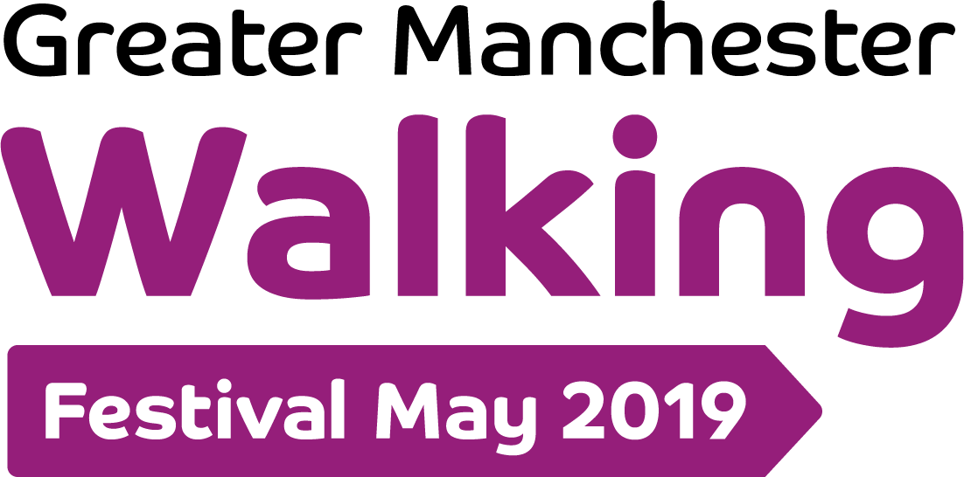

25th March 2019
BACK FOR THE 5TH YEAR:
GREATER MANCHESTER WALKING FESTIVAL 1ST-31ST May 2019

No matter whether you’re a stroller, roamer, shuffler, moocher or a marcher the
Greater Manchester Walking Festival (GM Walking Festival ) has something for you. Back bigger and better for the fifth year, it runs from Wednesday 1st to Friday 31st May, and offers 400 free guided walks exploring towns, cities, the countryside, canals, riversides and parks across Greater Manchester.

In 2019 the aim of the event is to encourage residents of Greater Manchester to rediscover their local area, reconnect with their friends and neighbours and to get out and about more. Walks cater for all abilities and interests, from a romp around Alkington Woods, Middleton to a scenic wheelchair-friendly ramble along the Bridgewater Canal.

The Festival is delivered by GM Moving, in partnership with Transport for Greater Manchester (TfGM) with support from local walking groups and charities.

As part of this year’s event, there are three themed walks honouring inspiring women of Rochdale, Manchester and Oldham. The first takes place on 5th May in Rochdale which starts at the Dame Gracie Fields statue, The Esplanade. On the 9th May there is a walk in Manchester City Centre from the Emmeline Pankhurst statue, St. Peter’s Square, and 19th May from Annie Kenney statue, Parliament Square, Oldham. The themed walks are led by knowledgeable Blue Badge accredited guides. The Festival is also working with We Stand Together and The Great Get Together campaign inspired by Jo Cox, to organise a Great Walk Together, that aims to connect walkers from across Greater Manchester at a central venue finale on 27th May. Free tickets for the themed walks and the Great Walk Together can be booked via Eventbrite.

Louise Robbins, GM Moving Walking Programme Lead, said: “The 2019 Festival is building on the great work from over the last four years. The event is the perfect excuse to kickstart an active lifestyle and to get outdoors more with the kids or a group of friends. Our ambition is to make Greater Manchester the first ‘Walking Region’ in the UK. The Festival is a fantastic chance to showcase and publicise the great walking opportunities and groups there are in Greater Manchester and to encourage people to walk more and get reacquainted with their local area.”

The full list of walks can be found at www.gmwalking.co.uk Copies of the Festival brochure, which details all 400 walks, are available in TfGM Travelshops and other outlets across Greater Manchester, including libraries and community centres.

Join the conversation and share photos and your experiences of walking in Greater Manchester on social media, follow @GMWalkingFestival on Twitter and Instagram and check out of Facebook page GM Walking Festival.

- ENDS -
Media Contact, Helen Dugdale, Scribble 07780 614898 Helen@scribbleaway.com
Editors notes
- Greater Manchester Moving (GM Moving) is the borough wide initiative to reduce inactivity and increase participation in physical activity and sport helping to positively change the lives of people across Greater Manchester.

- ‘We Stand Together’ is working across Greater Manchester to build understanding and respect between communities; celebrate our differences; act against hate and hatred; and build a safer and stronger Greater Manchester.

- In 2019, the GM Walking Festival have partnered with two inspirational charities: ‘The Jo Cox Foundation’ and ‘We Stand Together’, which both work hard to bring communities and people together - the walking Festival is one way to do this.

- The Great Get Together weekend is June 21-23rd 2019.

