

**Greater Manchester Coalition of Disabled People (GMCDP)**

**‘Help Through Crisis’ Project**

**Are you a young disabled person aged 15 to 25 living in Manchester?**

**Do you need?: • A**dvice/Advocacy

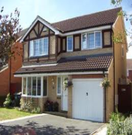**•**Support finding the right services e.g. housing, leisure, support services

•Support filling in forms to get benefits e.g. PIP (Personal Independence Payments)/Employment Support Allowance

•Anything else you need?

**Want to know more? Get in touch!**

Maureen Day: 0161 636 7535 [mday@gmcdp.com](mailto:mday@gmcdp.com)

**Greater Manchester Coalition of Disabled People (GMCDP)**

Unit 4 Windrush Millennium Centre

70 Alexandra Road, Moss Side,

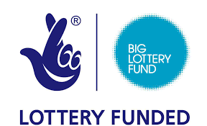Manchester, M16 7WD

Email: [info@gmcdp.com](mailto:info@gmcdp.com)

Website: [www.gmcdp.com](http://www.gmcdp.com) FB: [www.facebook.com/gmcdp](http://www.facebook.com/gmcdp) Twitter: @gmcdp