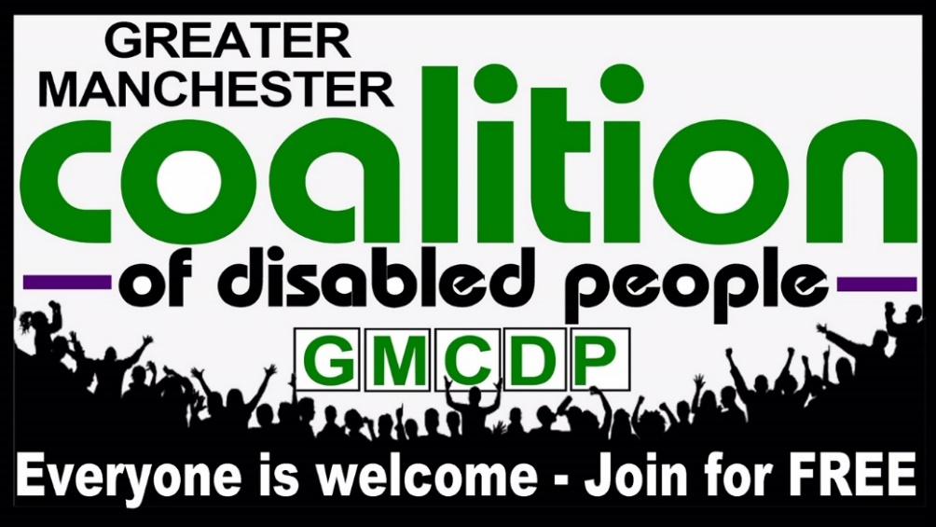

**Don’t leave it to others – Get involved TODAY!**

*‘I am a member of GMCDP because I believe it is a good way for disabled people to group together to effect change and stop the reversal of rights for disabled people’*

*GMCDP has changed my life. I see it as the building blocks of changing the world – or perceptions around disabled people. A stepping stone to a more inclusive society’*

GMCDP is celebrating 35years of activism and campaigning for the rights and full inclusion for all disabled people. We want more disabled people to get involved and carry on our work. Why don’t you visit our website or get in contact with us and find out more about what we do?

You can contact us by:

* phone 0161 636 7534
* email [phil@gmcdp.com](mailto:phil@gmcdp.com)
* facebook facebook.com/gmcdp
* website www.gmcdp.com/membership

**Don’t leave it to others, become a member today.**