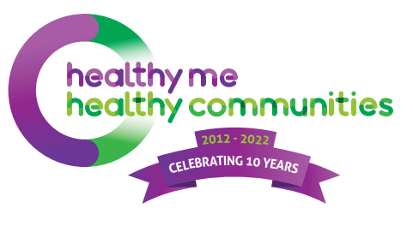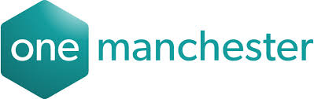
Gorton Food Hub
Expression of Interest

Please use this form to submit an expression of interest for holding a food project at the Gorton Food Hub at Gorton Central.
We are holding two information events where you can find out more about the Gorton Food Hub, ask any questions and provide your ideas. These will take place on Monday 25th April at 2- 3:30pm and 5:30 – 7pm at Gorton Central, Gorton Community Centre, Highmead Street, Gorton, M18 8PE.
Please send your Expression of Interest form in by 29th April 2022 Sally at the email address below.
For any enquiries please contact us on 0161 222 3633 or gortoncentral@hmhc.co.uk
Name of Organisation

Name of contact

Email

Telephone

Address

Website

Social Media

Year established

Status / structure
For example, charity, constituted group, CIC
If applicable, charity or company number
Do you have annual accounts? | YES /NO

- Please describe your organisation or group. How long have you been formed, where you are based and your status / structure?

- Please describe your services. What services do you provide and where from?

- What service would you offer from the Gorton Food Hub? Is it a new service or something you are already delivering?

- How do you source your food?

- Each approved food hub partner will be offered use of the Gorton Food Hub one day per week. Do you have specific days in mind for operational reasons? Please provide details.

- HMHC is committed to equality, diversity and inclusion and wants to ensure the Gorton Food Hub reaches the different communities of the neighbourhood. Please describe who accesses your services?

