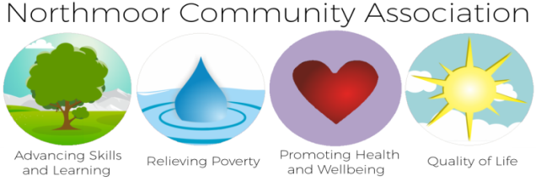

**Call Bradley 0161-248-6823**

**bradley@northmoorcommunity.org**

**Next Step Co-ordinator**

**Monday, Tuesday, Thursday & Friday 9:30 – 12:30**

[**www.northmoorcommunity.co.uk**](http://www.northmoorcommunity.co.uk)

**95 – 97 Northmoor Road, Longsight, Manchester, M12 5RB**

[**www.facebook.com/northmoorcommunityassociation**](http://www.facebook.com/northmoorcommunityassociation)

**Follow us on Twitter - @nmoor_community**

**Co. Reg. No. 4227867               Charity No. 1091595**

[**www.northmoorcommunity.co.uk**](http://www.northmoorcommunity.co.uk)

**95 – 97 Northmoor Road, Longsight, Manchester, M12 5RB**

[**www.facebook.com/northmoorcommunityassociation**](http://www.facebook.com/northmoorcommunityassociation)

**Follow us on Twitter - @nmoor_community**

**Co. Reg. No. 4227867               Charity No. 1091595**

**We can Offer**

**FREE Group or**

**One to One Sessions**

**at your centre.**

**Specialist Advisor**

**Informative Sessions**

**Advice & Support**

**Follow Up Work**

**Group Sessions between 2 – 3 hours**

**One to One Sessions by appointment**

**Northmoor Community Centre & Supportive Stem**

**Are you supporting Residents with HMRC Benefits?**

***Working Tax Credits***

***Child Tax Credits***

***Child Benefits***

***PAYE/Self-Assessment***







Group Sessions Minimum 8 –10 Booked in advance

One to One Sessions Minimum 4 - 5 appointments Booked in advance

**Northmoor Community Centre & Supportive Stem**