Interim Chair – 12 months

About Henshaws

Henshaws is a registered charity providing a range of services across the North of England to people of all ages, who are visually impaired and/or have other disabilities, including Autism and Complex Needs. We support people with sight loss or other disabilities to go beyond expectations, and we hugely value the energy, time, commitment and talents of our skilled Trustee Board who make it possible for us to achieve our aims. The Charity has entered an exciting time of development with significant potential for growth which requires the engagement of the staff and there is a Board keen to improve and learn.

To facilitate our further growth, we are currently seeking an experienced strategic leader with the interpersonal skills, professional knowledge and enthusiasm to act as interim Chair of the Trustee Board for a period of 12 months.

Key objectives include:

- To continue to ensure that the key charity and trustee risks are reviewed and appropriate action taken.
- To work together with the board and the executive to continue to develop the strong governance framework needed for the future.
- To put a process in place to recruit a permanent Chair.

Our mission and philosophy statements are:

To enable people with sight loss and people with other disabilities to reach their full potential in life and to live independent and fulfilling lives.

Our Values:

- Informed – always aiming to increase knowledge through experience, expertise and history.

- Sharing – desire to exchange experience and ideas with others

- Proactive – actively helping and supporting individuals

- Inspiring – through the life-changing impact on the people we support

- Compassionate – displaying empathy and understanding

- Empowering – encouraging and supporting individuals to reach their full potential.

To achieve this we employ well trained and motivated staff providing the highest standards of care and support, and a physical environment which is appropriate for visually impaired people and those with other disabilities. Our resources include a specialist college, a new autism centre, residential accommodation, supported living services and an Arts and Crafts Centre.

As the interim Chair of Trustee Board and in common with the other Board members, you will be required to deliver the leadership and coaching skills that ensure that the charity operates in a manner that enables it to fulfil its mission and embodies its values.

Our services

Specialist College
Our college offers specialist further education for students with a range of learning difficulties and other disabilities.

Arts & Crafts Centre
Our social enterprise provides vocational training for people with disabilities, and events and showcases for visitors.

Community Services
We work with visually impaired people of all ages, offering a bespoke package of support, activities and training.

Housing & Support
We provide local housing, and support people to live more independently in their own homes.

Training and services for businesses
We offer a range of services to help businesses including a qualification in Visual Impairment Awareness Training.

Disability Support Services
Our outreach services including therapies and rehabilitation can help people develop their mobility, independent living and communication skills.

Governance
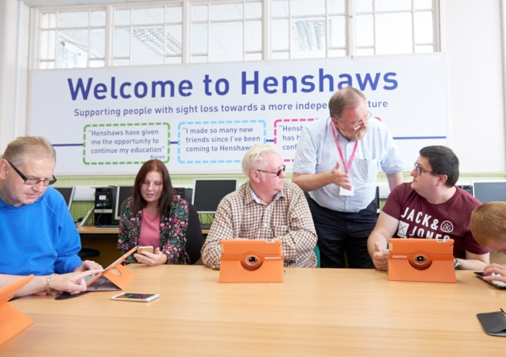
Henshaws is a Registered Charity (number 221888). Its Trustee is a Company limited by Guarantee (number 8813313, registered in England). The Trustee Board consists of the Directors of the Trustee Company, who are also its Members, who make the decisions of the Trustee. We have no political or religious affiliations. In the event of the Trustee Company being wound up the liability of each member is limited to £1.00.

General Duties of the Chair

- To govern in accordance with modern charity governance standards by:
  - developing strategy, vision and mission
  - ensuring the values and ethos of the charity are maintained
  - driving the impact of the charity’s work and progress towards goals and objectives
  - managing the charity’s resources responsibly
  - managing Board performance
- To regularly attend and chair Board meetings and relevant sub-committees.
- To debate issues with other Board Members and members of the Charity’s Senior Management Team in a manner that encourages others to participate and shows respect for, if not agreement with, their views.
- To analyse information and challenge constructively.
- To respect the boundaries between executive and governance functions.
- To maintain confidentiality on sensitive and restricted information.
- To participate in self-assessment of the Board’s performance.
- To ensure that the charity’s activities are within the law and its charitable objective and that the Trustee Board operates within its powers under the Articles of the Trustee Company.

The person we seek will be:

- enthusiastic and passionate about services for disabled people
- an excellent communicator and with strong coaching abilities
- able to create the environment for a high performing board team
- forward-thinking, with an ability to generate long-term plans that support a clear vision
- willing to drive the strategic direction of the charity
- confident dealing with people working at an executive level
- able to understand and accept the legal duties and responsibilities of Chair-ship
- willing to devote the necessary time and effort to their duties
- demonstrate sound independent judgement and integrity

Eligibility

Some people are disqualified by law from acting as Trustees, including:

Anyone who has an unspent conviction for an offence involving deception or dishonesty

Anyone who is an undischarged bankrupt

Anyone who has been removed from trusteeship of a charity by the Courts or Charity Commission for misconduct or mismanagement

Anyone who is disqualified from being a company director under the Company Directors Disqualification Act 1986

If you decide to apply to us, you will be asked to complete the statement on our application form confirming your eligibility.

Accountability

As a Trustee, you are accountable to:
- Service users
- Members
- Funders
- The Charity Commission
- Companies House

Time Commitment

There are usually four formal meetings per year; which include one as a Strategy Day (March), one to approve the three year Business Plan (September) and two general business meetings. Although Board meetings are held in Manchester a number of our services are based in Yorkshire and we would like to build our Board representation in this geographical area as well.

In addition there are a number of specialist sub-committees (see separate chart) and Board members are encouraged to represent the Board at one or more of these committees, depending on available time to commit. Some of these committees meet in Harrogate and others in Manchester.

Benefits

The Chair role offers considerable opportunities to make a difference in the local community, develop new skills, meet new people and improve career prospects.

Out of pocket expenses

Volunteers will be reimbursed for reasonable and receipted out of pocket expenses. (Mileage, parking, public transport etc)

DBS & References

Trustees will need to provide contact details for two referees and may be required to complete a satisfactory Disclosure and Barring Services check at enhanced level; costs for this will be met by the charity.

Like to find out more?
An informal discussion about this opportunity with our CEO can be arranged on request by emailing Recruitment@henshaws.org.uk

Interim Chair Application Form
Name: ………………………………………………………………
Why do you want to join and Chair the Trustee Board for this 12 month appointment?

What experience and skills would you bring to Henshaws?

What experience do you have of stepping into interim position, and/or of change management?

What experience can you offer of charity governance and leadership?

Do you have any experience of visual impairment or other disabilities - particularly learning disabilities and autism - either personally or through work or other settings?

Do you have any particular requirements regarding access or consider yourself disabled in
any way?

References: Please give us the name and contact details of two people we can contact for a reference about you.

Referee 1:

Full Name: …………………………………………... Email ………………………………………..

Address (only needed if email is not known) ………………………………………………………………………………………………………………
…………………………………………………………………………………………………………….

Telephone number …………………………………………………

How you know this person …………………………………………

How long you have known this person …………………………….

Referee 2:
Full Name: ……………………………………………… Email ……………………………………...

Address (only needed if email is not known) ………………………………………………………………………………………………………………
…………………………………………………………………………………………………………….

Telephone number ……………………………………………………

How you know this person ……………………………………………

How long you have known this person ……………………………..

Declaration
Do you know of any reason which would prevent you from becoming a company director or a charity trustee, e.g. undischarged bankruptcy, unspent conviction for deception or dishonesty, or previous removal as a charity trustee on these grounds? Yes / No

I declare this information to be true.

Signed: Date:

Thank you for taking the time to complete this application form. Please return a signed copy, along with your CV, to Helen Dewhirst, HR Business Partner, FREEPOST RRBX- YHBH-TKLL, Henshaws College, Bogs Lanes, Harrogate, North Yorkshire HG1 4ED, email Helen.dewhirst@henshaws.org.uk by 12 noon Friday 5th May 2017.

