Latest news from Greater Manchester Health and Social Care Partnership

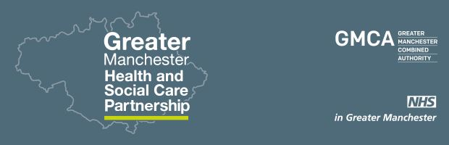

20,000 cancer champions needed in Greater Manchester
The search is on for 20,000 Greater Manchester ‘cancer champions’ who will use their experience and knowledge to support those at risk of developing cancer and those recently diagnosed with the disease.

This exciting new initiative aims to support people to take charge of their own health and wellbeing, and help those with cancer get diagnosed and treated earlier.

Click here to find out more and see below for a video
Sign up to be a champion here

Watch gardening dynamo Dena Murphy's story on ageing well
Up the creek with twenty paddles: a blog by chief officer Jon Rouse

First-ever Population Health Plan for Greater Manchester is launched
Our ambitious plan targets all stages of life, puts strong focus on prevention and how better health and wellbeing helps with work prospects and economy.

The plan will complement the individual work in the ten areas of Greater Manchester – and highlights where issues can be tackled more effectively by working together from a Greater Manchester stance.

It’s also the product of thousands of conversations last year with the people who live and work in this area about how they could take charge of their own health.

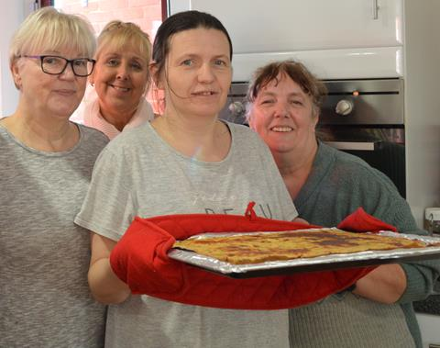
Find out what's cooking ...
Read more about the MoU

Devolution first for the VCSE sector - new agreement to support engagement
A historic memorandum of understanding has been signed between the Partnership and the Voluntary, Community and Social Enterprise sector in Greater Manchester, comprising of nearly 15, 000 organisations. Greater Manchester has become the only area of the country to formally recognise the contribution and importance of the voluntary sector in designing and delivering health and social care services.

Visit by Surrey Stakeholders
A delegation of senior leaders from North West Surrey CCG and Surrey County Council visited Greater Manchester early in the New Year to learn more about health and social care devolution.

Led by Julia Ross (pictured above), Chief Executive of North West Surrey CCG, the visitors met with Partnership chief officer Jon Rouse and colleagues to hear about our devolution journey to date.

In return, they shared information which Greater Manchester could learn from. These include community care locality hubs and the Epsom Health and Care urgent and emergency care system.

Jon Rouse will visit Glasgow this week on a further learning exchange.

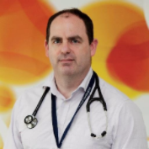

A new model of primary care
20 new Focused Care practitioners are being recruited by Hope Citadel Healthcare to work alongside GPs to help patients who are facing multiple and challenging health and social care problems.

John Patterson (picture above), GP and Medical Director at Hope Citadel Healthcare, said: “often these patients are invisible to the NHS. However, they turn up frequently and randomly at acute services and can place huge pressure on the system".

"Focused Care is about assessing the situation that these patients find themselves in and then working out a care plan with them to help them resolve their health and social care issues."

The programme will be evaluated by New Economy.

Locality News
Plans for a £60m expansion of the Citylabs campus on Oxford Road have been submitted and if approved - the development is expected to boost the city’s economy by £100m bringing 750 jobs to the region by 2020.

The new development is being proposed by Manchester Science Partnerships in a joint venture with Central Manchester University Hospitals NHS Foundation Trust.

For more - click here
Board news
Jeremy Hunt, Secretary of State for Health attended Friday’s meeting and spoke positively about our devolution journey, saying that Greater Manchester has made “extraordinarily significant progress towards integrated health and social care and has gone further and faster with work than anywhere else in the country”. He also said that the Prime Minister has committed to finding a long term solution to funding social care. View our board papers here.

Welcome to Diane Whittingham
Diane Whittingham has been appointed as Associate Lead for acute and specialist care at the Partnership. She will work closely with the 15 NHS trusts in Greater Manchester to establish consistency and best practice as well as delivering significant improvements for patient outcomes.

Diane has more than 30 years’ experience of leadership and management roles in the NHS.

A new service
Police, health, criminal justice and voluntary agencies have come together to deliver a new service to support vulnerable people across Greater Manchester. We will be working in partnership to provide support to people in custody, the courts and in the community to address issues such as mental ill health and substance abuse. More here.

Lead for equalities
Warren Heppolette, our executive lead for strategy and system development is also leading on equality, diversity and human rights issues for the Partnership.

Follow him on Twitter here.

Next board meeting
This is on 24 February in Rochdale.
Papers will be published online. Look out for updates on our plans around homelessness, preventing suicide and transforming primary care.

