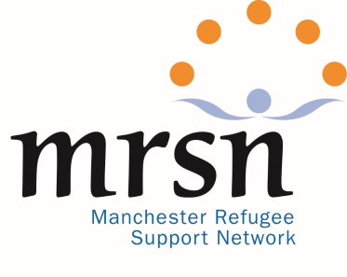
To Refugee Community Organisations in Greater Manchester
Do you need help to write funding bids?

If you would like to apply please:
- answer the questions below and return to roger@mrsn.org.uk as soon as possible and no later than 8th November 2020.
- answer the first six questions in full. Please answer the other questions as fully as you can.
- write as much as you like.

- Name of your group or organisation
- Person to contact:
- Name:
- Telephone/s:
- Email:
- Their role in your organisation:

- When was your organisation founded?
- Does you organisation have a set of rules or Constitution? (if possible please send it with this form)
- How many volunteers do you have?
- How many members do you have?
- How many paid workers do you have, if any?

- Please describe the main things your organisation does.
- How do you raise the money you need now?
- How has COVID affected what you do?
- What extra costs do you have because of COVID?
- Do you need money for anything else (apart from because of COVID)? If so, what?

When you have filled this form in please:
- keep a copy
- send it to roger@mrsn.org.uk with any documents you think may help us understand your needs.

The funding to pay for this help to your RCO is from:
