Manchester VCSE Health & Wellbeing Leaders Group

Purpose
- To provide a space for influencing, collaborative working, information sharing and discussion for VCSE sector organisations around health and wellbeing in Manchester.
- To act as a critical friend to the wider health and care system in Manchester.
- To provide the VCSE sector with the opportunity to consider and engage with the work of key public sector bodies in Manchester
- To facilitate VCSE sector representation on multi-agency working groups and for representatives to ensure good communication and effective working between the sector and these groups.

Functions
The Leaders Group has a number of formal responsibilities:
- Progressing the Memorandum of Understanding between MLCO and the local VCSE sector.
- Facilitating representation on key boards, steering groups and committees and ensuring there is regular feedback to and from the wider VCSE sector.
- Upholding good practice in sector representation and participation of the sector
- Convening, as required, additional meetings and conversations between public sector colleagues and VCSE leaders – including from beyond the membership of the Leaders Group.
- Holding a budget to support sector participation and any other activities as required.

The Group also has a number of additional aims it will pursue in the course of its work
- Ensuring the diversity of the city and its VCSE sector is reflected in our membership, our thinking and our conversations.
- Encouraging and supporting new and emerging VCSE leaders to engage.

Frequency of Meetings
The Leaders Group will meet at least every 2 months. A note of these meetings will be posted on the Manchester Community Central website.

Additional meetings and conversations may be arranged as required.

Chair of the Group
The role of the chair will be to facilitate meetings, liaising with Macc which will provide the secretariat and communications functions. The chair may also represent the sector at a number of key meetings and, at minimum will present a formal annual report to the MLCO Board and to the VCS Assembly. It is hoped that remuneration for the Chair’s time may if resources can be secured.

Membership
The group will be comprised of senior representatives of voluntary, community and social enterprise sector organisations which
- work in the health and social care sector in Manchester
- can dedicate time and effort to strategic engagement on behalf of the wider sector
- are willing to lead beyond their own direct interests including a wide range of smaller organisations and groups
- are members of Macc - as a means of verification of being a bona fide Manchester VCSE organisation

Criteria for membership of Macc are as follows
- Working within the City of Manchester and is not for profit
- Can demonstrate that their beneficiaries are the people of the City of Manchester
- Has three or more committee members with clear roles e.g. chair, treasurer, secretary
- Has clear aims, objectives or purpose (often in the form of a constitution, set of rules or other governing document)
- Can demonstrate financial accountability
- Signs a declaration expressing
- support for the purpose, values and beliefs of Macc
- support for Macc as the lead infrastructure body for the city’s voluntary and community sector
- support for the Manchester Voluntary Sector Assembly as the main forum for the voice of the voluntary and community sector in Manchester

The Leaders Group is not an open group as there needs to be a consistent, focused membership which has made a formal commitment to this work. The group is a coalition of the willing, leading on behalf of the wider sector and accountable back to the sector.

The group will draw its membership from as wide a range as possible. Membership will aim to have a of
- service provider organisations
- equalities organisations reflective of local communities
- Cover at least north, central and south Manchester
- Large and small groups

There is no formal limit on membership but it is expected to comprise around 15-20 members in order to be practical, cohesive and have some consistency of attendance.

Failure to attend successive meetings may result in membership being withdrawn.

Non-members will from time to time be invited to meetings or to take part in working groups and other discussions.

Accountability
The group is accountable back to the wider VCSE sector through the Manchester Voluntary Sector Assembly. The Chair of the Group will produce and present an annual report for the Assembly.

The Group will also engage with the Community Explorers meetings which take place in North, Central and South Manchester.

Information about the Group, representation, updates on activities and discussions such as blogs will be available on the Manchester Community Central website.

Below is a diagram which seeks to show how the Manchester VCSE Health & Wellbeing Leaders Group connects a range of formal structures and informal conversations to enable accountable collaboration between the public sector and VCSE sector:
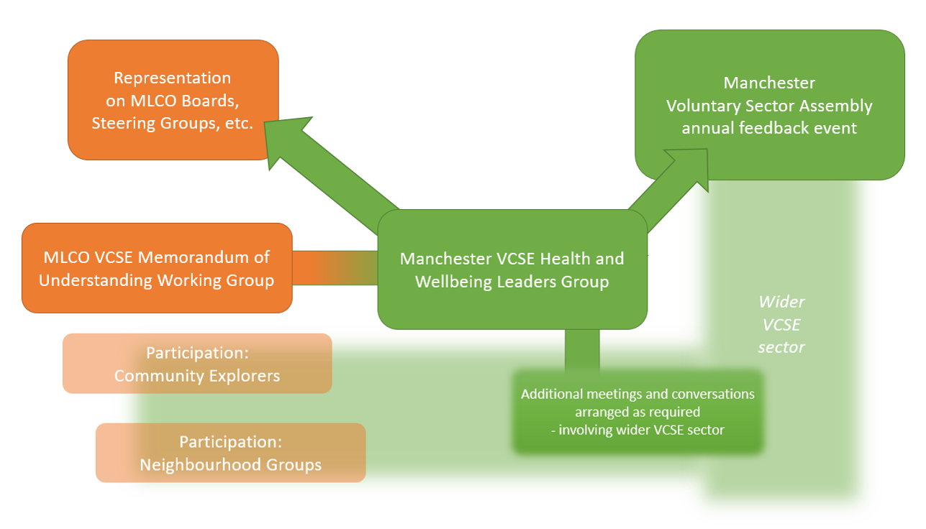
MLCO VCSE Memorandum of Understanding Working Group

Purpose
- To maintain the pace of work and commitment to the MLCO VCSE Sector Memorandum of Understanding, providing a space for and driving continued detailed negotiation and discussion.
- To monitor and evaluate the effectiveness of the MLCO VCSE Sector Memorandum of Understanding
- To act as liaison between MLCO and the Manchester VCSE Health & Wellbeing Leaders Group

Governance
This group is mutually accountable to the MLCO and VCSE sector and is formally a shared subgroup within our structures. It reports to the following:
- MLCO: via MLCO Head of Strategy
- VCSE sector: via Manchester VCSE Health & Wellbeing Leaders Group

The group will produce a formal annual report on the MoU. This will be presented to the MLCO Board with the presentation detailed in the minutes and a formal response from the MLCO Board.

Membership
VCSE sector: 3 members from the VCSE Health and Wellbeing Leaders Group (including the Chair)
Macc Chief Executive
Macc LCO lead
MLCO: ?
?
?
The MoU covers a wide range of issues – members may agree to bring in other colleagues where required for particular items.

Frequency of Meetings
Monthly

Chair of the Group
Chairing of meetings will alternate between MLCO and VCSE members.

