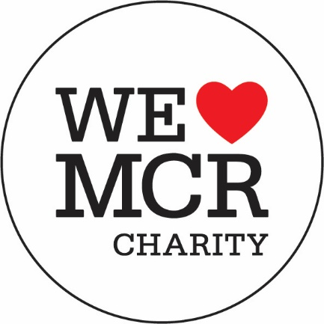

Mental Health and Wellbeing in Isolation Guidance (Covid-19 Community Response Fund)
The We Love MCR Covid-19 Community Response Fund welcomes applications from organisations that are delivering new or additional work in response to the Covid-19 Pandemic to support their communities around their mental health.
The purpose of the Fund is to provide financial support to Registered Charities and not for profit organisations who are working to address mental health needs that have been caused or exacerbated by the pandemic. The Fund in particular will support our most vulnerable and isolated neighbours and communities.
Key details of the Fund:
Beneficiaries of any award from We Love MCR must reside primarily in the city of Manchester (i.e not in the Greater Manchester boroughs)
This is a response fund. We are therefore offering funding to cover activities to be delivered within the next six months or less.
£50,000 is available in the Mental Health and Wellbeing fund. We aim to award grants to the value of £10,000 - £20,000.
The deadline for applications is 12th June 2020 at 5pm. We will aim to review your application and provide a decision within 2 – 3 weeks of this date.
We are especially welcoming applications from organisations working in partnership.
We ask that organisations who are thinking of making an application contact us beforehand to discuss their application. Please email us at welovemcrcharity@manchester.gov.uk to arrange a time to speak. We will not accept applications unless we have had a conversation first.
Who can apply:
- Registered Charities
- Not for profit organisations

What the Fund can and cannot support
The Fund is able to support:
- New staff costs and or volunteer costs
- Technology or Equipment costs
- Applications from organisations acting in partnership

The Fund is not able to support:
- Costs related to Fundraising events
- Projects which use our funds primarily to fund a staff member employed to raise further funds
- Requests that will replace Statutory Duty of Manchester City Council
- New Groups or organisations with no track record of delivery in Manchester
- Retrospective applications – i.e applications aiming to recoup already spent expenses.
- Applications for resources that are available via other sources / funds

Please note the above lists are not exhaustive and we reserve the right to extend them.
Filling in the form
Please answer all the questions on the form. Please be clear as to what you would like funding to achieve, who you will help, how many people you will help and what impact this will have.
This is a response fund we are therefore offering funding to cover activities to be delivered within the next six months or less – please ensure this is reflected in your costings.
The Grants are available to fund additional new activities. We do not intend to fund a share of fixed overheads and admin costs through these Grants
Applicants must demonstrate that their proposal is sustainable for the project period – for example if a project involves smart device connectivity, the credit provided to clients must last for the whole project period.
Applicants should show how their support adds value to, rather than replaces or replicates, the support available from other groups including statutory services. It should not provide resources available from other announced sources.

We will review your publicly available financial documents to help us assess suitability for awards. Please help us by ensuring you fill in the question about your finances (Question 3.3) as this gives us context and helps guide the decision making.
Supporting documents
Please remember to send the following documents along with your application – we will not review your application without them:
- Your governing document
- Annual accounts from your latest financial year available
- Your safeguarding policy
- Partnership agreement if you are applying in a partnership

How we make decisions
Applications and supporting documents will be reviewed by officers at The We Love MCR Charity. Recommendations will be made to the We Love MCR Trustee board for final decisions around awarding grants. The Officers at We Love MCR may contact you for further information or clarification to support this decision making process.
Monitoring and Celebration
If you are successfully awarded a grant we will ask you to send us information about who you have helped and the impact you have made. This will include sending us case studies, pictures and videos (where appropriate) of the work you do. This will form part of the award agreement.
We also require successful applicants to celebrate any award from We Love MCR and tag us on Social media during the life of the grant.

