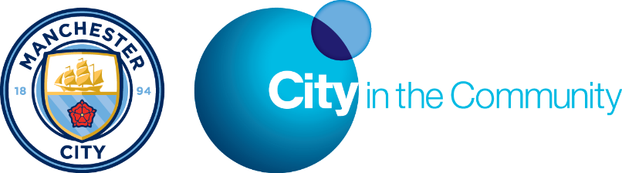
PREMIER LEAGUE WORKS PROJECT
City in the Community is the community programme of Manchester City Football Club and was originally formed in 1894 to combat anti-social behaviour, drug and alcohol, health issues and unemployment in the local community.
City in the Community create opportunities through football to engage with the local community and work to motivate and inspire people to achieve.
The PL Works programme is aimed at young people aged between 18 – 24 years who are currently not in employment, education or training and we are currently recruiting participants to start the programme in April 2017.
The programme is designed to provide opportunities and upskill participants whilst enhancing the CV and using the power of football to motivate people towards making positive steps in obtaining employment.
The programme will run for two days a week for an initial 13 week period (120 hours) (every Wednesday & Thursday commencing on 26th April 2017) and will also include a monthly jobs club (first Friday of the month), regular catch ups and follow up over the subsequent 12 months.
The programme will include a broad range of workshops including:-
*Transferrable Skills
*Employability Skills
*Job Searches
*Community Activation
*Wider Key Skills qualification
*Support in literacy & numeracy
*Work Placements
*Personalised development plans
*Regular sporting activities to help promote active and healthy lifestyles.

If you would like any further information or would like to make a referral, please contact Deborah Glynn, Employability Officer on 0161 438 7842 or deborah.glynn@cityfootball.com

