For immediate release

Andy Burnham addresses concerns about transport with Older People at Greater Manchester event.

On 17 January 2018, members of the Greater Manchester Older People’s Network came together to discuss and share their views on Age-Friendly Transport in the region. Speakers from Ambition for Ageing will be gave their perspective on the matter, and Mayor of Greater Manchester, Andy Burnham addressed some of the concerns that were raised by the network as part of an address. A panel discussion also featured representatives from the Greater Manchester Ageing Hub and Transport for Greater Manchester.

“Age-friendly transport is an extremely important issue for Older People that can make the difference between maintaining independence and social connections and becoming lonely and isolated. It intersects every area of peoples’ lives. We hope that by working with Andy Burnham, Transport for Greater Manchester and other key partners that we can address some of our members’ current concerns and help develop transport in Greater Manchester that meets the needs of all its citizens.”
(Liz Jones, Greater Manchester Older People’s Network Development Worker, Macc)

Stephen Rhodes, Director of Customer Services at TfGM said:
“Public transport can be a vital link for older people to get out and about to keep active and combat isolation.
At this event, we were able to listen to older people’s concerns and issues, and we will continue to work with partners across Greater Manchester to remove any barriers to older people using the transport network.”
For details about the Greater Manchester Older People’s Network contact Liz Jones at Macc on 0161 834 9823 or liz@macc.org.uk.
Links:
Periscope Stream of Andy Burnham's address:
https://www.pscp.tv/w/1RDGlnaBLRzxL
https://www.manchestercommunitycentral.org/civicrm/event/info?reset=1&id=5252
https://www.manchestercommunitycentral.org/policy-and-influence/gm-older-peoples-network
https://www.ambitionforageing.org.uk/
https://www.youtube.com/watch?v=Lry6uJllVA0 - Greater Manchester Devolution and the views of older people.

Twitter: @mcrcommcentral
@policyvoiceMacc
#GMOPNTransport

Image:

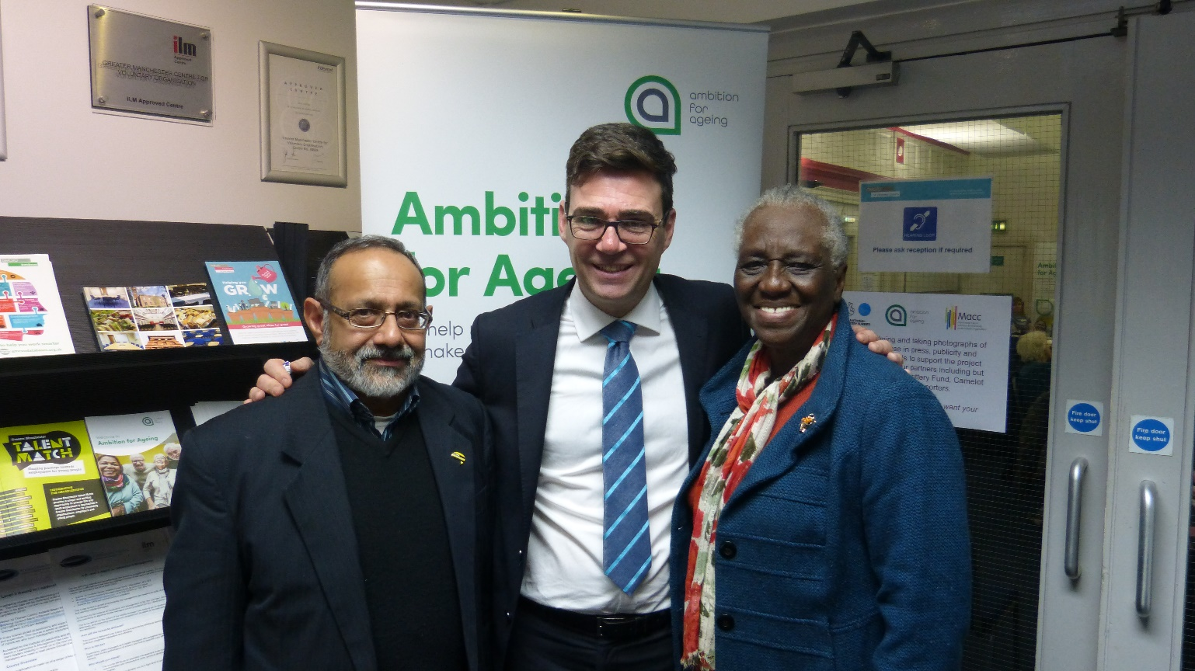

Andy Burnham with Greater Manchester Older People’s Network Members Jamil Abdulkader (Left) and Elaine Unegbu (Right)

END
--------------------------------------------------------------------------------------------------------
Notes for the Editor

About the Greater Manchester Older Peoples Network
The Greater Manchester Older People’s Network (GMOPN) provides an opportunity for older people to influence the decisions, services and policies that affect our lives.

GMOPN is facilitated by Macc and involved in the design, delivery and evaluation of Ambition for Ageing Programme, a Greater Manchester programme aimed at creating more age friendly places and empowering people to live fulfilling lives as they age. It is funded by the Big Lottery Fund’s Ageing Better programme, which aims to reduce social isolation of older people.

About Macc
Macc is the voluntary, community and social enterprise support organisation for the city of Manchester. Our purpose is to encourage, support and develop voluntary and community groups and individuals to have a real influence over the places and communities in which they live. Macc has been active in the city of Manchester since 1981.

About Ambition for Ageing
- Ambition for Ageing is a £10.2 million Greater Manchester wide cross-sector partnership aimed at creating more age friendly places and empowering people to live fulfilling lives as they age.
- Led by GMCVO, the 5 year programme is delivered by a cross-sector partnership with contractors leading on the work in 25 neighborhoods across 8 local authorities in Greater Manchester in addition to a number of scaled programmes across the city-region.
- Ambition for Ageing’s belief is that a series of small changes within our communities will bring large scale success in a practical and sustainable sense that will ultimately help to reduce social isolation.
- Its vision is to connect communities and people through the creation of relationships.

About The Big Lottery Fund
- The Big Lottery Fund, the largest distributor of National Lottery good cause funding, is responsible for giving out 40% of the money raised for good causes by the National Lottery.
- The Fund is committed to bringing real improvements to communities and the lives of people most in need and has been rolling out grants to health, education, environment and charitable causes across the UK. Since its inception in 2004 BIG has awarded close to £6bn.
- The Fund was formally established by Parliament on 1 December 2006.
- Since the National Lottery began in 1994, 28p from every pound spent by the public has gone to good causes. As a result, over £30 billion has now been raised and more than 400,000 grants awarded across arts, sport, heritage, charities, health, education and the environment.

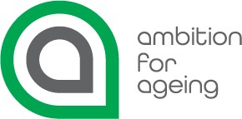

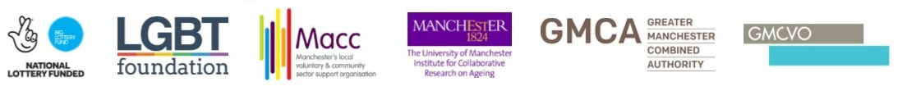

Contact:
Mike Wild
Chief Executive, Macc
T: 0161 834 9823
E: mike@macc.org.uk
Twitter: @MikeWildMacc
Macc, Swan Buildings, 20 Swan Street, Manchester M4 5JW

