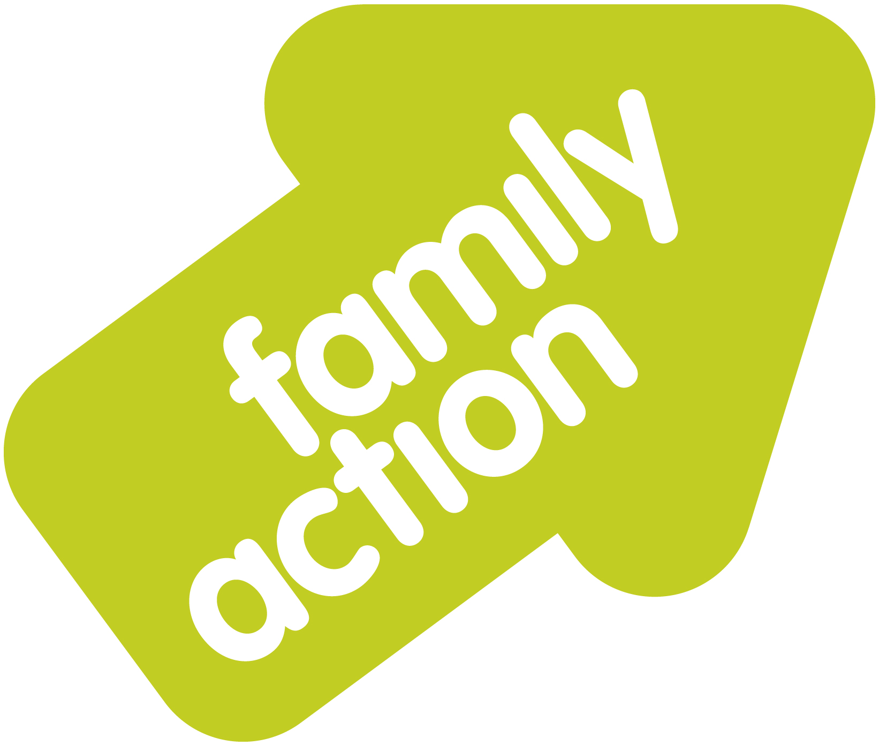
Family Action Manchester Young Carers Service
Caring role identified – need for support
Contact Family Action Young Carers to discuss referral;
- 0161 682 1500
- rachel.leah@family-action.org.uk

Discuss the referral with the family/young person and obtain consent.
Complete MCAF SECTION 1/Young Carers Appendix and fax/email to 0161 274 7082/cafit@manchester.gov.uk
Fax/email/post copy of completed forms to Family Action Young Carers Service
Contact the MCAF Team via fax on 0161 274 7082 or email cafit@manchester.gov.uk to clarify whether an MCAF has previously been registered.
Referral will be processed/logged. A letter will be sent to referrer & family highlighting next steps and approximate timescales for assessment.

Referral Pathway;

