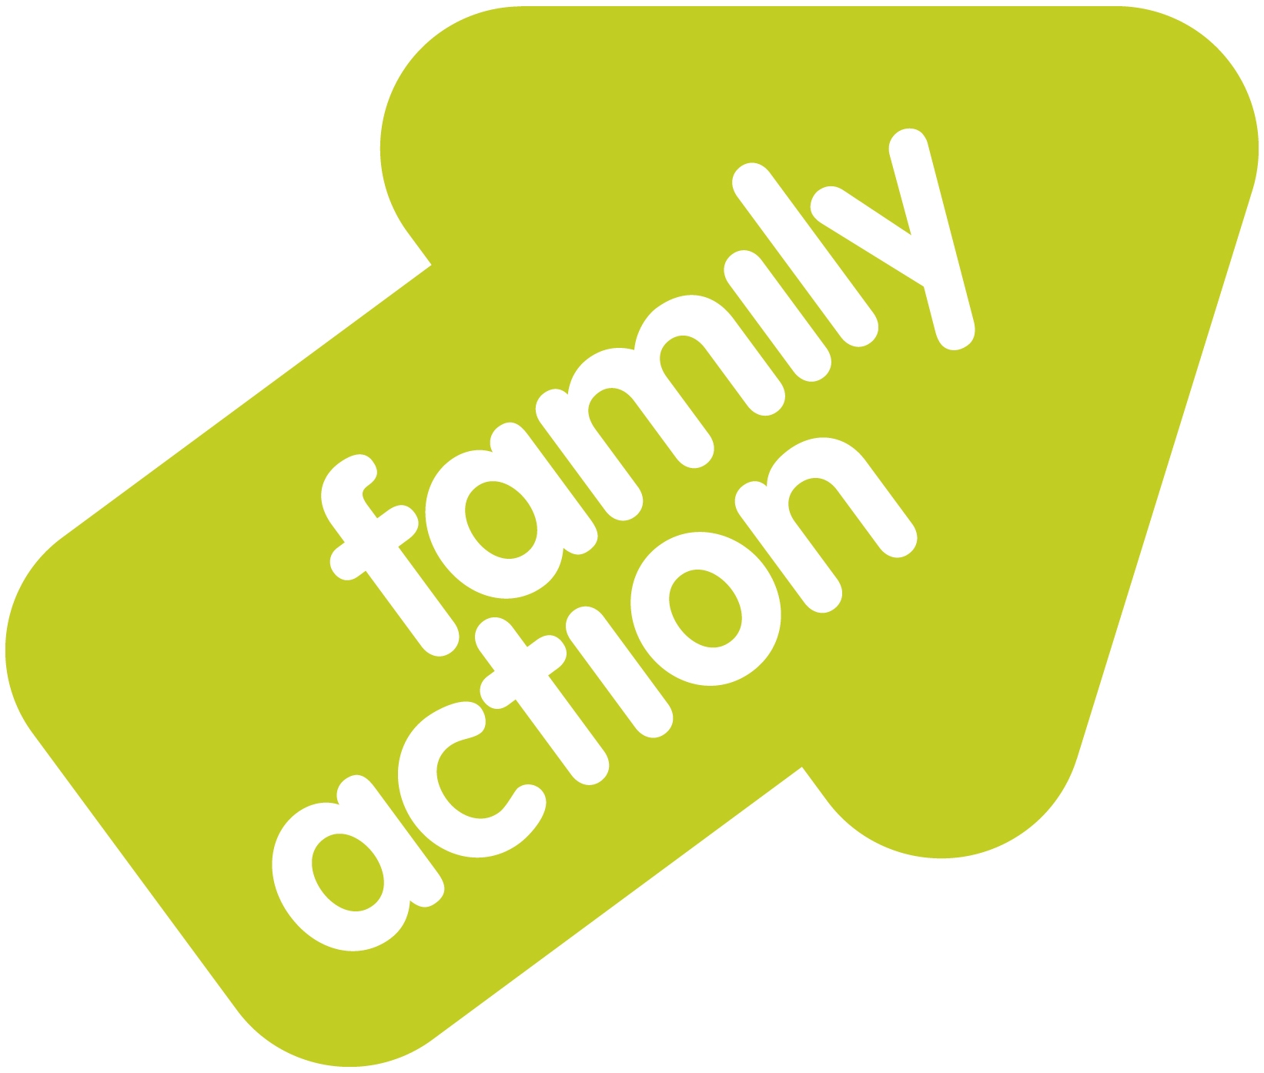

Dear Referrer,

Family Action Manchester Young Carers have been commissioned by Manchester City Council to provide a city wide family support and respite service for young carers aged 8 -18.

We are in the process of making alterations to our current referral process and have been liaising with Manchester City Council and the MCAF Team to incorporate the MCAF (Manchester Common Assessment Framework) into our work with Young Carers.

In line with this from July 8th we will be asking professionals to use the Section 1: MCAF Registration form alongside a short appendix form in order to refer young people/families into our service. The information included within the form is no different to the information requested within the previous referral form but the process does require that an MCAF is opened and registered with the MCAF Team. This registration process is simple and easy and can be done via an email to cafit@manchester.gov.uk. Please note that consent must be obtained before an MCAF can be registered so you will need to speak to the family prior to making a referral.

Once this form is completed and returned, and the MCAF registered, we will then act as the initial Lead Professional for the Young Carer and proceed with a full assessment of need.

We have attached a copy of the new referral pathway as we want to ensure the process is as simple and understandable as possible and in all cases Family Action’s details should be inputted in Section 6 highlighting them as the organisation who will carry the MCAF forward to Section 2..

In addition to this we continue to invite professionals/staff to contact us should they have any queries regarding a possible referral and we will support accordingly.

Please be aware that any referral received after July 8th which does not comply with the new referral system will not be processed.

