**See More, Learn More , Go Further!! E- Resource pack**

**The See More, Learn More, Go Further Project!** Is a Greater Manchester initiative led by the NHS aimed at encouraging children to have regular eyesight tests. For National Eye Health Week **18th September -24th September 2017**, the Greater Manchester Health and Social Care Partnership have created a number of e-resources. Please support the improvement of children’s eye-health by promoting this project via any screens you may have (e.g. waiting rooms).

If you would like any hard-copy resources, please email [**sarah.ward22@nhs.net**](mailto:sarah.ward22@nhs.net)

Leaflet

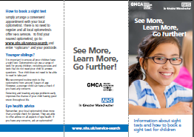



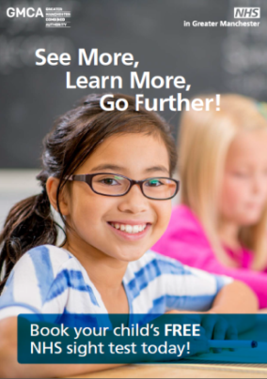

Poster



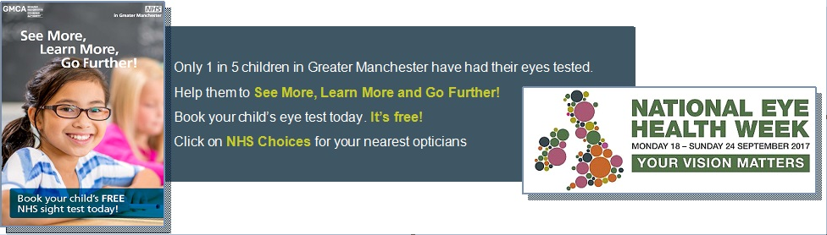

Email Footer



[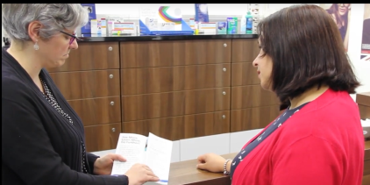](https://wetransfer.com/downloads/84a486b3884c989402eb57e1497d699920170915091157/233ff93d0068725083208f0bca16319120170915091157/9c05f0)

Video Eye testing – Click on link to download file.

E-link for Children’s presentation (online only) <https://www.powtoon.com/c/d4qCZn8Ym42/1/p>https://www.powtoon.com/c/d4qCZn8Ym42/1/p

[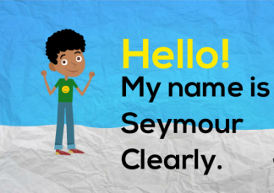](https://www.powtoon.com/online-presentation/d4qCZn8Ym42/?utm_campaign=copy%2Bshare%2Bby%2Bowner&utm_medium=SocialShare&utm_source=player-page-social-share&utm_content=d4qCZn8Ym42&mode=movie)

PowerPoint Version

