C:\Users\huw\Downloads\Untitled-1.tif

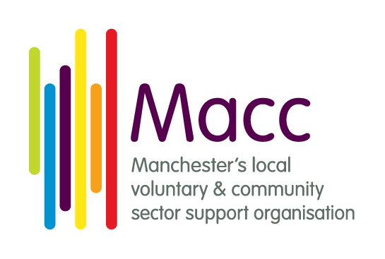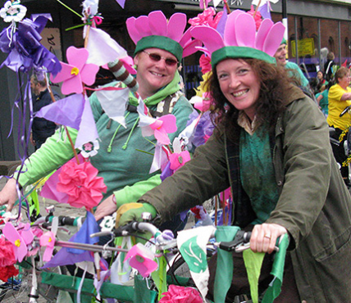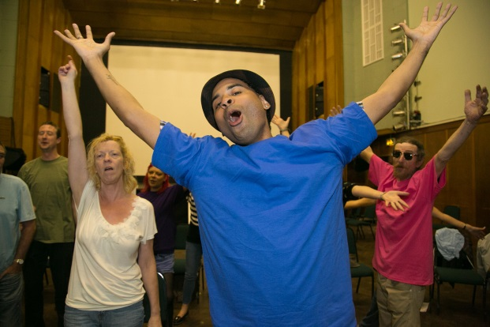

**Join in!**

Hold an event between 1 – 10 October to showcase your organisation and the great activities and services you deliver

**#SpiritofMcr16**

**Website:** [**bit.ly/1XwrXO8**](http://bit.ly/1XwrXO8)

**Facebook: @spiritofmanchester**

**Twitter: @McrCommCentral**

By working together to provide a brilliant Festival, we can magnify the impact of the VCSE sector. We gain a bigger voice on a bigger platform and show people the difference that we’re collectively making within the community!

For more information and to get involved, contact Adele on 0161 834 9823 or at [adelep@macc.org.uk](mailto:adelep@macc.org.uk)

Streetwise Opera (photo by Matt Priestley)

Simply Cycling

Would you like to raise awareness of your organisation?

Celebrate your community and the work you do together?

Recruit new supporters, volunteers and funds?

**1 – 10 October**

**2016**

**The annual city-wide celebration of Manchester’s voluntary, community and social enterprise (VCSE) sector**