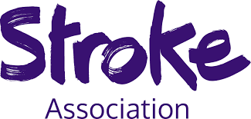

Stroke Community Choir
Do you enjoy music and signing along to the radio? Then come along and join our choir – just for fun!
Stroke survivors, carers, volunteers, professionals – all are welcome.
Join our singing workshop and unwind in a friendly relaxed atmosphere – it’s good for you too!
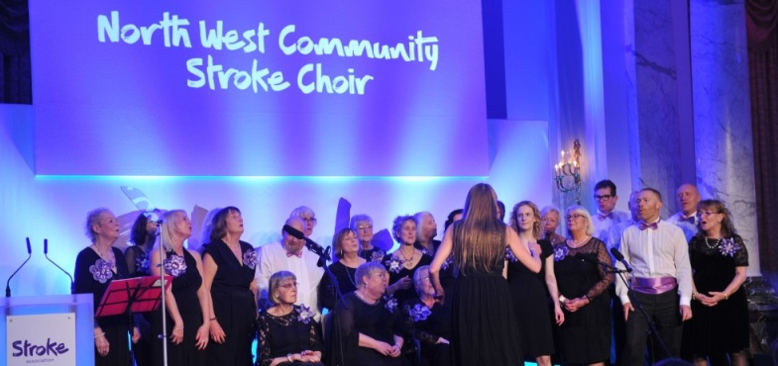
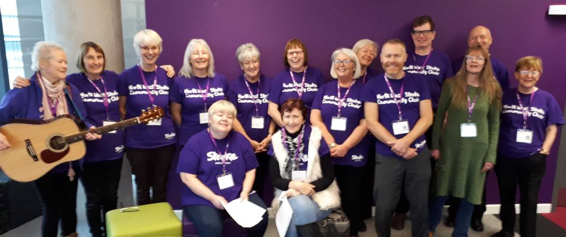

Supported by Simply Singing.org.uk

Dunelm Mill, Pausa Café, St Marys Way, Stockport, SK 1 2HU
Alternate Mondays 6pm – 7:30pm

Please contact: Joyce Booth 07392 843 973 joyce.booth@outlook.com

