Contents | Page 1
Introduction | Page 2
Aims | Page 2
How can you help / Expression of interest | Page 3 / 4
Your role | Page 4
Assets | Page 5
Review | Page 6
Useful Links | Page 6

Introduction
NHS Greater Manchester (NHSGM) launched its winter vaccination programme at the beginning of September. The programme was brought forward this year following the emergence of a new Covid variant.
All those who are eligible are being urged to get vaccinated against flu and Covid-19 as soon as possible for the best protection this winter.
The immunosuppressed, carers, pregnant women, adults under 65 identified as clinically at risk due to health conditions, and health and social care staff will all be among the groups to be offered a covid jab this winter, as well as adults aged 65 and over. 2 and 3 year olds and school aged children will also receive a flu vaccination.
Eligible people will receive an invite from their local GP and pharmacy or via national texts and letters.
Flu and Covid can be unpleasant. But for many people, particularly those with certain health conditions, older people, and pregnant women, they can be dangerous and even life-threatening. Catching both viruses over winter increases the risk of serious illness.
Covid vaccines can be booked via the NHS App, on the NHS website or by calling free on 119. Or walk-in Covid vaccine clinics are available – with no appointment needed.
Flu vaccines for adults are available at GP practices, local pharmacies, and some maternity services (for pregnant women). Pharmacies offering this service can be found via the NHS website.
There’s no need for people to wait for an invitation before booking to have a flu vaccine or a Covid vaccine. The latest information on winter vaccinations in Greater Manchester, including Covid vaccine walk-in clinics is available on the NHS Greater Manchester website
The flu vaccine is being given to children as a quick and painless nasal spray. Those aged 2-3 years can receive the vaccine at their GP practice and older children will be vaccinated at school.
Aim of this project
This project focuses on clinically at-risk groups between the ages of 16 and 64 years. There are nearly 300,000 people in Greater Manchester that currently fall into this category and its important that we do all we can to encourage them to get protected this winter to prevent severe illness, hospitalisations and deaths arising from Covid 19 and flu. The table below lists these groups and the numbers eligible in GM.
We are asking for the support of our local voluntary, community, and social enterprise sector in GM to support us in promoting vaccinations to these groups and to help us understand some of the lived experiences of patients who are immunosuppressed.
Using this insight, we hope to develop some targeted and relevant communications assets for social media and campaigns that enable us to reach this target group.
We also want to understand their experiences and any barriers or opportunities within the system to support their access to the vaccine programme.

For further information on category data for immuno-suppressed patients please click HERE.
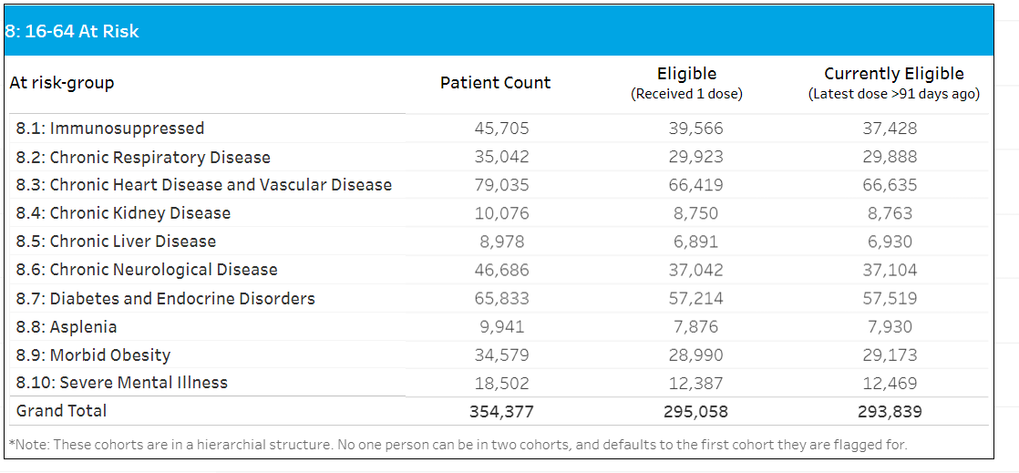
How can you help?
NHS Greater Manchester are reaching out to the VCSE sector, enabling community groups and organisations to run small engagement events targeting the Immuno-suppressed patient profile.
We are offering a small funding opportunity up to £1000 per locality in Greater Manchester.
This will enable you to host/facilitate smaller engagement events in your community. We would be looking at a minimum of 2 events up to £500 each or a collection of smaller funded events to enable us to achieve our aim.
You can also help by becoming active in promoting our assets (below) via social media platforms to best disseminate the key and core messages covered more in your role.
If you are interested in supporting our aims, please email the following with your expressions of interest:
Scott Williams (Engagement Manager): scott.williams8@nhs.net
Celeste Bain (Engagement Manager): celeste.armitage@nhs.net

Expression of interest
Your expressions of interest email should include the following:
- Name of organisation/group
- Contact person, job title or role and contact information.
- Description of project, including:
  - Venue,
  - Proposed time and dates,
  - How you intend to engage people. (a brief description of methods you may use)
  - Numbers you expect to target and how these will be targeted.

- Funding amount required.

- Who will be responsible for the project if different from the named contact person.

  - Please can you also share your organisational structure information including the following:
- Copy of your organisation rules
- Proof of bank details (a company letter head with your bank details on and a copy bank statement from the past 3 months)
We welcome any other comments or information you wish to share with us relevant to your expression of interest for this project.
Your role

We will be hosting an online session to enable you to understand the key messages, ask questions and discuss the roles and responsibilities. It would be expected a representative attend this briefing which will be sent to you on acceptance of your expression of interest.
We will be providing physical assets that would require collection.
Members of NHS Greater Manchester Communications and Engagement Team will be supporting the programme of work in localities and could offer direct support to your delivery, this would be discussed with you directly.
During the activities you deliver we would like you to speak to people about:
- The challenges people face due to their illness and how this may be a barrier to accessing the vaccine programme. Are their other issues around their needs that we ned to consider i.e. family dynamics, work, travel etc.
- How might we overcome these challenges and barriers people face, what could we offer or do differently.
- We would want you to motivate patients to access their vaccine, this can be done by using the key messages and supporting people to make an informed decision.
- Myth Busting is key to challenging certain preconceptions and miss information, in the useful links section Covid 19 guidance doc.

Assets
It’s so important to promote the vaccine programme and we are asking that where possible our partners and stakeholders support by sharing the attached content on their social media feeds to assist the NHS in reaching as many people as possible.
Key Messages for immuno-suppressed patients/household:
- For extra protection this winter get vaccinated against flu and COVID -19
- If you have a weakened immune system due to a health condition or medical treatment, this means you have lower resistance to infection. This means It’s easier for you to catch flu or COVID and you’re more likely to become seriously ill if you do. Vaccination provides extra protection to help keep you well this winter.
- You may have a weakened immune system or be ‘immunocompromised’ if you are living with HIV, have had a transplant, or are receiving treatment (e.g. steroid tablets) for conditions such as cancer, lupus, or rheumatoid arthritis.
- Vaccination against flu and COVID vaccination is safe and effective – it provides the best protection against these viruses. Don’t worry if you have missed previous COVID boosters, it won’t make the vaccine any less effective and it’s never too late to get the protection you need.
The vaccines can still work even if you have a weakened immune system. They are not live vaccines so they cannot harm you when your immunity is reduced.
- For extra protection this winter:
- Book an appointment at your GP practice.
- Book online (or call 119) to go to a pharmacy providing this service. Some pharmacies may also offer a walk-in service.
- Ask your hospital specialist.
- Vaccination reduces the risk of someone catching flu or COVID and then passing it on to others. That’s why other members of your household (aged 12 years and over) are also eligible for free NHS vaccines this winter.

Key behavioural changes:
- Challenge misconceptions directly by giving out NHS England or NHS Greater Manchester information.
- Support, signpost people to book their appointment.
- Support people’s commitment to their appointments by communicating positive messages.
- Prompt people to add reminders on their phone/email calendars to help with their attendance.
- Reframe the flu as a serious condition – talk about the flu and covid as a disease not as a “cold or common cold”.

All assets can be found by accessing our: Dropbox or our Google Drive:
Please contact the NHS GM campaigns team if you have any problems downloading from these links – gmhscp.gm-campaigns@nhs.net.

Review
It is requested that information, insight and any detailed minutes or conversations are collated and sent following your event date. These should be sent to Scott Williams and Celeste Armitage via the emails above.
Feedback can take many forms (qualitative and quantitative). NHS Greater Manchester are not prescriptive on how these events should be delivered. We acknowledge the important role the VCSE sector play in communities and wish to empower and enable contact and sharing of information.
Feedback may include:
- Case Studies.
- Feedback forms.
- Anecdotal conversation.
- Written statements.
- Poster designs.
- Voice notes or video.
Please find our template feedback form:

Useful Links
  - How to book a vaccine through a pharmacy: Find a pharmacy that offers the NHS flu vaccine - NHS - NHS (www.nhs.uk)
  - About Covid 19 Vaccine: About the COVID-19 vaccine - NHS (www.nhs.uk)
  - Covid 19 Guidance for people whose immune system means they are at higher risk: COVID-19: guidance for people whose immune system means they are at higher risk - GOV.UK (www.gov.uk)
  - Myth Busting - (library.nhs.uk)

Thank you for your time and consideration.

