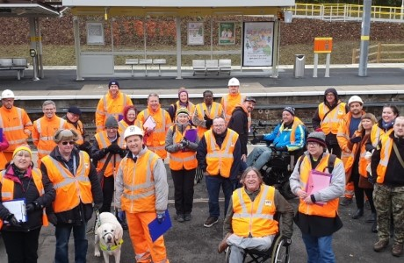

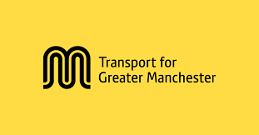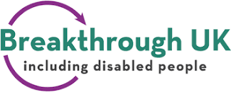

Job advert

Vacancy for paid member: Transport for Greater Manchester, Disability Design Reference Group

- Are you a disabled person, or do you have lived experience of disability or a long-term health condition?
- You may also work in an organisation supporting people with lived experience of disability or long-term health conditions.
- Are you passionate about helping to create inclusive public transport, walking, cycling and wheeling services across Greater Manchester?

Breakthrough UK, a leading disabled peoples user led organisation, is recruiting members to join the Disability Design Reference Group (DDRG).
The DDRG is an award-winning advisory group set up to assist Transport for Greater Manchester (TfGM) in designing requirements for an integrated, accessible public and active travel transport network.
As a DDRG member you will provide advice based on lived experience of your impairment, including physical and mental health, and as an independent user of public transport systems and walking, cycling and wheeling routes across Greater Manchester and as an independent user of public transport systems and walking, cycling and wheeling routes across Greater Manchester.
Greater Manchester is on a journey to delivering a joined-up, sustainable and inclusive transport system which supports safe, seamless and affordable end-to-end journeys across public transport and active travel – the Bee Network.
Improving our public transport and active travel is crucial to connecting people with key services and opportunities, as well as being central to Greater Manchester’s ambition of becoming carbon neutral by 2038 and facilitating the future growth of the city-region.
As a key part of the Bee Network, buses are being brought under local control and will be planned and coordinated by TfGM, on behalf of Greater Manchester Combined Authority (GMCA), in the biggest change to public transport in the city-region in nearly 40 years.
Through the delivery of the Bee Network, TfGM’s role is changing. TfGM is moving from being a principally infrastructure focussed organisation to one that is a more inclusive and customer focussed. TfGM want to develop and deliver a network which puts people and places at its heart, informed by a deep understanding of the residents and communities and their different transport needs. The ongoing role of DDRG is integral to this change.
In addition to attending formal quarterly meetings, group members will have opportunity to contribute to ‘task and finish’ opportunities around specific requirements which may be in-person and/or site visits, planning and reviewing sessions, joining other meetings or reviewing and inputting into documents and communications as helpful.
To apply for this role you must live or work or volunteer within the boundaries of Greater Manchester. We particularly welcome applications from disabled people facing racial inequalities, young people and from people who have never done anything like this before.

Duties include:
- To comment on TfGM and its Partners work and make recommendations for improvement.
- Impart advice which helps to provide an appropriate level of access to The Bee Network, the integrated transport network for Greater Manchester, composed of bus, tram, cycling walking and wheeling routes, as well as other TfGM projects for disabled people.
- Be a member of collaborative working groups with Officers across TfGM and its Partners to improve services.
- Advise on and participate in appropriate communication and marketing activities in relation to the public transport projects.
- Attend site visits to advise on physical accessibility across bus, tram, walking and wheeling.
- Proactively provide feedback and recommendations for the future DDRG work programme.
- Contribute to the ongoing evaluation of the DDRG.
- To be a positive, respectful, active-listening, problem-solving supportive group member.

We would expect a commitment to attend 4 quarterly meetings per calendar year. There will also be opportunity to advise on ad-hoc meetings. There may also be site visits.

Access and communication support, such as sign language interpreters or advocates, will be provided.

Quarterly meetings are virtual and involve processing the information in advance and typically a 2-3hr zoom meeting . We will support you to get online if you need this. Meetings may be in person if this is required by TfGM.

You’ll receive £75 per meeting, plus limited travel expenses within Greater Manchester.

There will also be 2 paid training days per year.

The position as a DDRG member is for 2 years, with possibility of extension to 3 years.

Please note that this is a self-employed position and you will be responsible for paying your own tax and National Insurance through self-assessment.

To apply for this role please tell us:
- More about you, including your contact details
- Why you would like to be a member of DDRG
- What you think about public transport in Manchester

You can tell us these things by:
- Sending us up to 500 words in your preferred format, or by
- Sending us a short video or audio file of you talking or signing - up to 5 minutes in length.
If you need more information on any of this, please text or phone Helen Clark on 07706 733768.
Information is available in alternative formats on request to meet access needs.

Please apply by 9 June 2023.
Email Helen via: h.clark@breakthrough-uk.co.uk to apply, or
WhatsApp your video or audio to 07706 733768.

If successful in your application, we will contact you for an informal interview.

We look forward to hearing from you!

