‘What’s On’ Central Newsletter October 2017

Compiled by the Community Inclusion Service

Connect
When it comes to wellbeing, other people matter. Evidence shows that good relationships with family, friends and the wider community, are important for mental wellbeing.

Inspire Levenshulme Community Centre
747 Stockport Road, Levenshulme, M19 3AR; Mon to Sat. 9am to 5pm. Office 0161 850 5717;- Cafe 0161 850 4747.for community activity, Cafe with Fresh-made, Training facilities,.
Happy Mondays Group for over 50s (2-4pm) Film Club, Pamper sessions and trips out.
Grow Club Tuesdays 1.30 – 3.30pm. Run in partnership with Whitworth Art Gallery’s Grow Project that promotes benefits of engaging in activities to help mental wellbeing.
Older People’s Lunch deal Mon – Fr 12 – 3pm 2 course meal for £3 (register at Inspire)

Peer support group @ Inspire Levenshulme Café – Thursday at 1-3pm

Northmoor Community Association
95 – 97 Northmoor Rd, Longsight, M12 5RT. Office 0161 248 6823
Friendly and welcoming community centre with lots of opportunities.

IT courses (Food Hygiene, City and Guilds, First Aid, Health & Safety)/ Help setting up emails/ developing IT skills Mon, Tues, Thurs & Fri 9.30 -12.30pm. Walking Group on Fri at 10am.

Talk English Sessions Wed, Thurs, Fri 9.30 – 11.30 Practise speaking and writing English in an informal setting.

Community Café every Wednesday 12 – 2pm. Healthy meals for just £1, tea/coffee and cakes all at great prices.

Different volunteering roles available, such as homework club volunteer, Café/Baker, credit union volunteer.

St Lukes Church and Neighbourhood Centre
Guidepost Rd Longsight
Manchester M13 9HP
(Corner of Devonshire St South and Stockport Rd)

People can access a range of support, advice and activity. St Lukes provides a friendly and informal meeting place for people to share a cup of tea, a meal or join in an activity. They offer a holistic range of services which promote mental and physical well being.

Drop In sessions on Tuesday (4 – 7 ) and Thursday (12.30 – 2.30). Hot healthy snacks/meals available for a small charge. Come along and share a cuppa and meet new people. New Knit and Natter group started on Thursdays 1.30 – 3pm.

Holistic therapies are also available by booking. Call 0161 273 1538 for more details.
Art project runs at St Lukes. Contact Alison for more info 0161 273 1492. Wide range of art sessions, including women only sessions on Mondays 12 – 4.
St Luke’s Centre provides a great opportunity for people to build their social networks and develop confidence and self esteem.

The Pankhurst Centre Women’s Drop In
Thursday 11 – 2pm
All women welcome to attend social group to meet new friends and have fun. Lunch is included
The Pankhurst Centre
60 – 62 Nelson St
Manchester
M13 9WP

Gorton Community Centre
Highmead St, Gorton, 0161 223 1516
All welcome to attend the activities at the centre. Try something new, have fun and make friends.
Monday Keep Fit Class 10 – 11am £1.50
Tuesday Line Dancing or Tai Chi 10 – 11am £1, Craft Stitch 12 – 3pm (fee paid to tutor)
Wednesday Art Class 10 – 12 Free, Yoga 7- 8.30 (fee paid to tutor)
Thursday Art/Cross Stitch 10 – 12 (fee paid to tutor), Zumba 7 – 8pm £1.50
Friday Armchair exercise 12.30 – 1.30 Free

Number 5 Richmond Street Manchester M1 3HF

Groups

Horizon (formally Carousel)
2nd and 4th Tuesday of the month 7:30pm – 9pm
A relaxed social group for lesbian and bisexual women and for those who are questioning their sexual orientation.

Icebreakers
Every Wednesday, 8pm - 9.30pm
A mutual support group for gay and bisexual men who are ether just ‘coming out’, who are already ‘out’ but new to the area, or who are experiencing feelings of isolation. Icebreakers is facilitated by a trained and dedicated team of volunteers who provide a free, safe, confidential and welcoming space in which group-users can meet each other in order to form supportive and enduring friendships and social networks. For more information, please visit www.icebreakersmanchester.org.uk, e-mail them at icebreakersmanchester@hotmail.co.uk

Imaan
1st Friday of the month, 7:30-9:30pm
Imaan is a support group for LGBT Muslims. Please get in touch for more information.
Email info@imaan.org.uk, or visit www.imaan.org.uk.

Better Things
Meeting on the 3rd Monday of the month, 6:30pm-8:30pm
We offer you friendly and confidential support, for adults with learning difficulties who want to feel safe and happy to talk about being gay, lesbian, bisexual and transgender.
If interested and for more information please call Brenda on 0161 728 7616.

.

Be Active
Being active is great for your physical health and fitness. But evidence shows that it can also improve your mental wellbeing.

FRIDAY 2 – 4pm
Stephen Charles Pool Hall
5 – 11 Cheetham Hill Rd
M4 4FY
Have a game of pool, meet new people and have fun.
The first session is free and then £2.50 per session.
Please call in for a chat or call Beth on 07568533975
Zumba
Mondays 7 – 8pm Active lifestyle Zumba at St Lukes Church Devonshire St Ardwick 0161 273
1538. £1 cost
Hatha Yoga at Inspire
Fridays 6.30 – 8.30pm
£5/£3 (concession) per class. Call Magdalena on 07507474001 for more details and to book a place

Thai Boxing at Inspire
Tuesdays 7.15 – 8.15pm
Newcomers welcome, £4 per session. Contact Howard on 07766915313

Active Lifestyles Simply Circuits Class
For anyone who hasn’t done much physically activity and would like to start off with some exercise in a fun and friendly environment try this class. Wednesday 12 – 1 at St Lukes Church, Devonshire St. Cost £1. If you want to find out more about Active Lifestyles and the sessions call 0161 234 5454.

Swimming at Manchester Aquatic Centre
Interested in swimming? This session will help you get your confidence back in the water and improve your swimming ability. Every Friday 10:30 –11:15; Cost: £1; Venue: 2 Booth Street East, Ardwick, M13 9SS. Contact: 0161 234 5454. Also available at other location and in the afternoon. www.manchester.gov.uk/activelifestyles
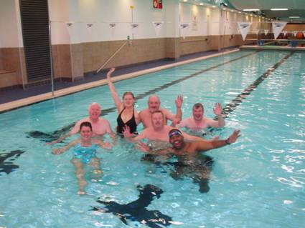

Swimming pools & Gym at Arcadia Levenshulme
Two swimming pools, a 60-station gym, sauna and steam room, dedicated community studio and library.
Yew Tree Avenue, Levenshulme, Manchester, Lancashire M19 3PH
Phone:0161 224 0938
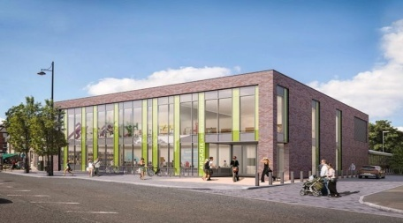

Go for a walk or run. Step outside. Cycle. Play a game. Garden. Dance. Exercising makes you feel good. Most importantly, discover a physical activity you enjoy and that suits your level of mobility and fitness.

St Johns Centre
St Johns Rd,
Old Trafford,
M16 7GX
0161 872 7795

Boot Camp
Men & women
Thursday 11.30 – 12.30
FREE for 30 weeks (New Beginnings fund)
All new body work out, exercises to burn fat and tone you up.

Keep Fit
Women only sessions
Feel good, look good.

Aerobics and Body Tone Pilates Step Aerobics
Tuesday 1.30 – 2.30pm Thursday 10.15 – 11.15am Friday 5.30 – 6.15

All sessions £2. Creche (limited places at £2 per child)

Walking groups supported by NHS Health Walks
Monday:
Manchester Velodrome Indoor Walk 2pm
Tuesday:
Gorton Park 11am (meet at Manchester City Chapel, Crossley St)
Debdale Park (meet at the kitchen) volunteer led – 10.30am-11:45am

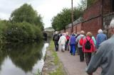
Wednesday:
Clayton Vale (short and longer walk options) – 10.00am
Heaton Park (30 mins short/slower walk) - 12pm (smithy lodge entrance, outside golf cafe)
Moston Marchers (Broadhurst Sure Start) volunteer led 12pm
Manchester Velodrome Indoor Walk (meet on 1st Floor) - 1.30pm-2.30pm
Thursday:
Manchester City Stadium Nordic Walking – 09.30am (meet at sport city gym cafe) £1 for pole hire. (Not part of Walking for Health)

Friday:
Manchester Velodrome Indoor Walk (meet on 1st Floor) -11am

Walking at Union Chapel
On the first Saturday of the month, meet at 9.30am. If you plan to come then please call Lorna on 0161 225 3835 to find out location of walk and latest details.

Urban gym

Time to Get Fit with the Urban Gym
Come and try the Zion Centre’s Urban Gym! Designed for low impact exercise, our equipment is specialised in developing your balance, raising your cardio and increasing you flexibility.
We are open from Monday – Friday 9.00am – 5.30pm (7.30pm on Tuesday and Thursdays) and from 10.00am – 2.00pm on Saturdays. The Gym is Free to use! But you will need to fill in a Gym Joiners Form and return it to reception.
Equipment:
- Air Skier: Improves Cardio and Balance
- Air Walker: Improves Cardio and Flexibility
- Bike: Improves Cardio and Flexibility
- Elliptical Cross Trainer: Improves Cardio and Flexibility
- Rider: Improves Strength and Cardio
- Seated Leg Press: Improves Strength and Flexibility
- Thai Chi Spinners: Improves Flexibilty and and Balance
For more info call Zion Centre 0161 226 5412

Gentle Exercise at Union Chapel, Wellington Rd, Fallowfield, M14 6EQ
Monday 11.15am – 12pm
£3 per session
Lou 07818466761
Maintain physical health by combining gentle aerobic exercise with joint limbering movements. Suitable for people who haven’t exercised for a while/older people.

Time to put on your dancing shoes!
Dancing can be a great way of keeping in shape, having fun and meeting people.

Brazilian/Cuban dancing
Wednesday 10 – 11.30 at Kath Locke Centre 123 Moss Lane East 0161 455 0211. Donation to attend

Dance session at Westcroft Centre, 24 – 26 Westcroft Rd, Burnage, M20 6EF. Contact Hazel Roy 0161 434 5021. Mondays 10 – 11am, first class is free then a £3 charge per session.

Varied dance class at Union Chapel, Wellington Rd Fallowfield. All styles of dance, rag time, classical and rock and roll to name a few! Wednesday 10.30 – 12.30, first session is free. Contact Hazel Roy 0161 434 5021.

Play some music and sing a song or two!

Drumroots
West African Djembe Drumming
Every Tuesday at Union Chapel. Visit www.drumroots.org.uk or call Jamie on 0161 408/07939 749 099.
Beginners warm up 6.30 – 7.30pm £5/£4 (conc) and main workshop 7.30 – 9.30pm £6/£5 (conc). Both sessions £7/£6(conc) +£1 drum hire(or bring yourown).
Fun and energizing session. All levels welcome.

Singing at St Johns Centre, St Johns Rd,Old Trafford,M16 7GX 0161 872 7795
Wednesday 7.30 – 9.30pm Shylarks Harmony Singing
Friday 1 – 3pm Singing for the brain(Alzheimers Society)
Please contact the centre for info about costing

TAKE NOTICE
Be curious. Catch sight of the beautiful. Remark on the unusual. Notice the changing seasons. Savour the moment, whether you are walking to work, eating lunch or talking to friends. Be aware of the world around you and what you are feeling. Reflecting on your experiences will help you appreciate what matters to you.

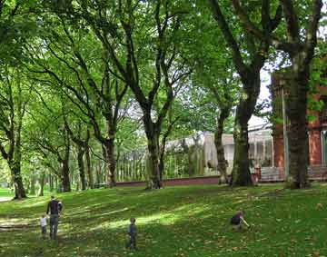

Holistic Therapies & more
Zion Centre, 339 Stretford Rd M15 4ZY 0161 226 5412
Massage therapies available with male and female therapist. £10 waged and £5 unwaged. Mon 10 – 4pm. Homeopathy (appointments only) £10 per session. Please call for an appointment.

Mind and Body Balance
Female Therapist, offers Hypnotherapy; including smoking, weight loss, psychotherapy , mindfullness; Tel. 07908 681758; Manchester Therapy Centre, 77 Russel Road, M16 8AR

Relaxation
With Self Help Services at Zion Community Resource Centre, 339 Stretford
Road, M15 4ZY

Meditation
Weekly Programme at Kagyu Ling Buddhist Centre, 45 Manor Drive, Chorlton cum Hardy M21 7QG.
0161 850 4450
Mondays 10 – 11am, Tuesdays 8 – 9pm, Wednesdays 10.30 – 11.30am & 8 – 9pm
Everyone is welcome to attend – no experience necessary. Suggested contribution £3 towards running costs of the centre

Mindfulness at Inspire, Levenshulme
Wednesdays 7 – 8pm
No need to book just drop in. £5 per session or £45 for block of 10 sessions. More info contact Phil on 07852174391

Learn Something New

Flexing mental muscles and learning something new raises confidence and distracts from some mental health stressors. Learning with others, meeting new people, expanding social networks and sharing mutual goals and interests. Independent learning. Enrolling on a course on line, or studying things you are interested in.

Talk English Sessions
Fallowfield library
Platt Lane
Manchester
M14 7FB
0161 227 3744
Come along on Thursdays 10 – 12 to practice speaking English and meet new people.

English Conversation
Take the opportunity to practice speaking English. Every Wednesday 1 – 2.30pm.
The Chrysalis Centre,
4 Westerling Way,
Moss Side
M16 7EA
Free sessions, everyone welcome. With University of Manchester Student Volunteers.

Back On Track

Want to improve your life through learning new skills! Such as: IT, Computers, Digital Photography, English & Maths, Cooking... The service is inclusive to homeless; people with mental health problems
You are welcome.
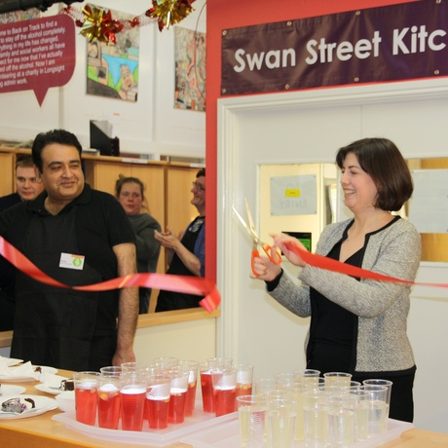
Back On Track – Swan Building, Swan Street, Tel.0161 834 1661;
www.backontrackmanchester.org.uk

Manchester Adult Education
Internet & Digital Skills; English & Maths; Work clubs & Employability (Create a
CV, Job search); Being a Volunteer & Applying for jobs; Health & Social Care; Childcare...
Different locations: Longsight Library & Adult Learning Centre, @ 519 Stockport Rd, M12 4NE,
0161 227 3706. Greenheys Adult Learning Centre, @ Great Western St,Moss Side, M14 4HZ, 0161 254 7314.
http://www.manchester.gov.uk/adulted

Get up to date with technology

Gorton Library, Garrett Way, Gorton M18 8HE 0161 227 3737 Thursdays 10 – 1pm
Longsight Library, Stockport Rd, Longsight M12 4NE Tuesdays 9 – 4.30pm
Digital drop In for basic computing. Expand your skills and learn basics at ICT help sessions.

Local History Group
Discover more about Gorton/Manchester history
Popular and friendly group meets at Gorton Library on Tuesday 2 – 4pm.
0161 227 3737

Opportunities and Activities
Union Chapel
Wellington Rd,
Fallowfield
M14 6EQ
0161 225 4226

A friendly and welcoming learning venue with a wide range of opportunities, ranging from Spanish, Italian, Pilates, Portrait painting and Current Affairs.

WEA COURSES
0300 303 3464
Wide range of courses at various locations in Manchester, concessionary fees for people on certain benefits.

Painting and Drawing – Inspired by the Art of Artists from Africa
Gorton Community Centre, Highmead St, Manchester M18 8PE
Starting on Weds 4/10/17 at 10am (20 weeks)

Psychology: How we differ as Individuals
Fallowfield Library, Platt Lane, M14 7FB
Starting on Monday 30/10/17 at 1.30pm (6 weeks)

History: Black History at the People’s History Museum
People’s History Museum, Leftbank, Spinningfields, M3 3ER
Starting on Friday 13/10/17 at 1pm (5 weeks)

Give
Small acts of kindness towards other people, or larger ones – such as volunteering in your local community – can give you a sense of purpose and make you feel happier and more satisfied about life. For example, a 2004 study in 373 older adults found that some aspects of wellbeing were higher in those who did volunteering projects, compared with those who did not.

Volunteering
Volunteering your time can be incredibly rewarding and creates connections with the people around you. Giving your time in a Community Garden Centre can improve your wellbeing. Manchester Volunteer Centre MACC can help you with online registration, Induction and other support; Tel. 0161 830 4770, MACC 3rd Floor, Swan Buildings, 20 Swan Street, Manchester M4 5JW - 10:00 – 5:00 pm
www.manchestercommunitycentral.org

Volunteering Opportunities
Volunteer for the Zion Community Resource Centre and learn a wide range of skills and have the opportunity to meet new friends.
- Reception/Administration
- Centre Hosting
- Community development
- Develop new groups
- Help with Events
- Arts and Crafts
- Gardening
- Domestic and Maintenance and much more
For more details please contact Anna Akhtar anna.akhtar@biglifecentres.com or call Zion on 0161 226 5412
Gardening @ Debdale Eco Centre
Become a volunteer at Debdale Eco-Centre - Food growing for well-being based in Gorton. Open every Tues & Weds 10-3.30 @ Debdale Park, M18 7LJ. 220 9199. www.debdale-ecocentre.org.uk

Volunteer at Northmoor Community Centre.
Give something back to the community, wide range of volunteer roles available such as café assistant, IT helper and homework club assistant. The centre has volunteer sessions every fortnight on Thursday afternoons 2 – 3.30pm. Contact the office for more info 0161 248 6823

Will Griffiths Court
Retirement Housing Scheme,
Moss Side

There are a variety of ways to get involved from Monday to Friday including: Art class, Brunch Club, Exercise & Wellbeing, Entertainment and IT class. Contact Katie.roberts@onemanchester.co.uk for more information or call 0161 227 1313.

Volunteer Inductions at Inspire : once a month, please ask at reception for a form.

Roles available : Chefs, cooks and café assistants. Event organizers to help with one off events. Working with older people. Inspire ambassadors to promote Inspire.
747 Stockport Rd, Levenshulme, M19 3AR.
0161 850 5717

For more information on volunteering opportunities contact Manchester Volunteer Centre, Swan Buildings, Swan St 0161 830 4770

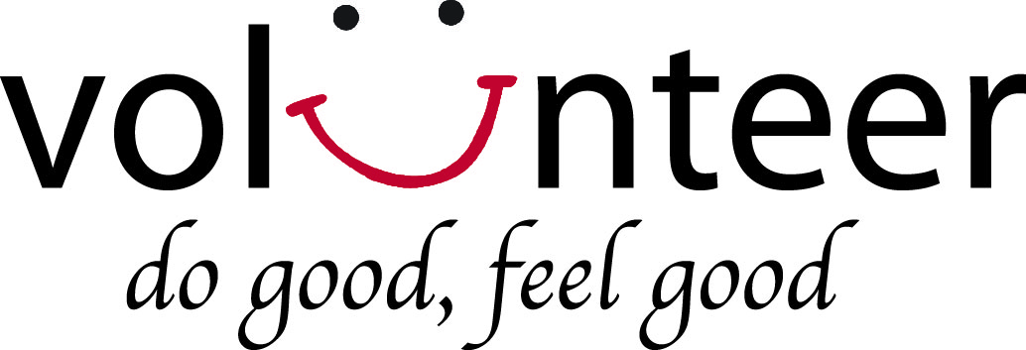

What’s on for the over 50’s
All the activities already included can be accessed by people of all ages. The following activities are aimed at people over the age of 50.

Golden Voices Choir
Thursdays 10.30 – 12.30
Band on the Wall, Swan St
Julie Jones 07906201262
The choir is looking for new members, first session is free, there after £3.50 per session.

Exercise and Eat
Tuesdays 11 – 2pm at Inspire, Levenshulme
Gentle chair exercise session (£2) to build strength and balance, followed by a 2 course meal (£3). Ring in advance if you need transport to attend 0161 850 4044

Computer Club at Westcroft Community Centre Tuesday 12.30pm. 0161 448 8232

Just for Men computer session. Do you need help with computers, I pad or phone. Want to meet people, have fun or join in with a game of scrabble. Friday 2 – 4pm Chorlton Library

Line Dancing at Burnage Community Centre. Wednesday 1.30pm. 0161 431 7220

Sewing Group at Westcroft Community Centre. Fridays 10am. 0161 448 8232

Simply Loving Knit – Knitting Group at Westcroft Community Centre. Wednesday 1pm. 0161 448 8232.

Painting Group at St Werbergh’s Church Hall, Chorlton on Tuesday at 10am. 0161 8811642.
Mindfulness – Beginners course at Union Chapel on Wednesdays at 1pm.

Singing for Fun at Ladybarn Community Centre on Wednesdays at 1.30pm. 0161 256 2779.

Walking Football at Whalley Range Power league Wilbraham Rd on Tuesdays at 11am. 0161 881 8442.

Zumba/Pilates at Withington Methodist Church on Wednesday at 6.30pm. 07762047938.

Zumba Gold at Hough End Leisure Centre on Fridays at 11.30am. 0161 641 6300.

Coffee morning at Chorlton Central Church on Tuesdays at 10.30am. 0161 881 0958.

Coffee morning and Art Class at Wilbraham St Ninians on Thursdays at 10am. 0161 881 2925.

Coffee Fellowship at Withington Methodist Church on Tuesdays at 10.30am. 0161 445 3539

Coffee and chat meeting at Withington Library every Wednesday 1 – 3pm 0161 227 3720

This list is not exhaustive but provides a snapshot of activities in your local area. We are unable to provide information on the quality of individual services.
Kind Regards.

In Crisis (Useful numbers):

Ring & Ride - Manchester One, Portland St, Manchester M1 3LD . Tel. 0845 688 3989
Ring & Ride is designed to make short, local journeys, helping you to: do your shopping; travel to work, school or further education college; attend health appointments, including visits to hospitals and medical centres;take part in social and leisure activities; and visit places of worship.
Samaritans - Calling Samaritans is now free of charge from a landline or mobile. Their new number is: 116 123 (24 hours every day) www.samaritans.org

SANEline - 0300 304 7000 (6 -11pm every day) www.sane.org.uk
A specialist mental health helpline that is now a local-rate, 0300 number. Calling the helpline costs no more than calls to geographic (01 and 02) numbers from a landline, and is included in inclusive and free minutes on mobiles.
SANE also offers ‘Textcare’ - a way of providing emotional support and connection for anyone affected by mental illness, including families, friends and careers. Having a mental health condition, or caring for someone who does, may leave you feeling distressed, lonely or isolated. Contact from SANE via text can provide an important source of support. ‘Textcare’ provides help at times that are relevant for you, for instance:
• A regular time when you may feel lonely or isolated, for example at weekends or when other services or support are not available.
• A specific time when you would like some extra support, for example before attending an appointment. The service provides one text per week for five weeks. If you would like to continue the support beyond this time, simply re-submit the form below. This is NOT a crisis service. If you need support in a crisis, please refer to their crisis page
Ring NHS 111 by dialling 111

Moodswings - 0161 832 3736
helpline from 10am to 4pm Monday to Friday www.moodswings.org.uk

Crisis Point - 0161 225 9500 http://www.turning-point.co.uk/crisis-point.aspx

Manchester MIND - 0161 226 9907 or email at info@manchestermind.org www.manchestermind.org

CASS ANY AGE Women's Self Injury Helpline 0808 800 8088 www.selfinjurysupport.org.uk

No Secrets – supporting those affected by self-injury www.no-secrets.org.uk

The Sanctuary - 0300 003 7029 (phone 24hrs a day 7 days a week. Open doors 8pm-6am)
www.selfhelpservices.org.uk/sanctuary

LGBT Number 5 Richmond Street Manchester M1 3HF
Helpline and email advice
You can email the helpline anytime at helpline@lgbt.foundation and we will reply to you within 10 working days.
If you feel you need immediate support then please try calling our helpline on 0345 3 30 30 30

If you already have contact with mental health services:
- Contact your local Community Mental Health Team (CMHT)
- Contact your crisis team if you have one.
Self Help Services 0161 226 3871 www.selfhelpservices.org.uk
communityservices@selfhelpservices.org.uk (lists workshops/groups and drop-ins)

Mental Health in Manchester (resource website) www.mhim.org.uk

The Community Inclusion Service: provides a range of flexible one-to-one support, peer support, and short courses: a clear support plan via realistic goal setting around *Managing the persons mental health *Accommodation needs *Finances *Community inclusion *Relationships and support networks *Work readiness *Physical Health www.gmmh.nhs.uk Contact Tom Martin 01612192340

