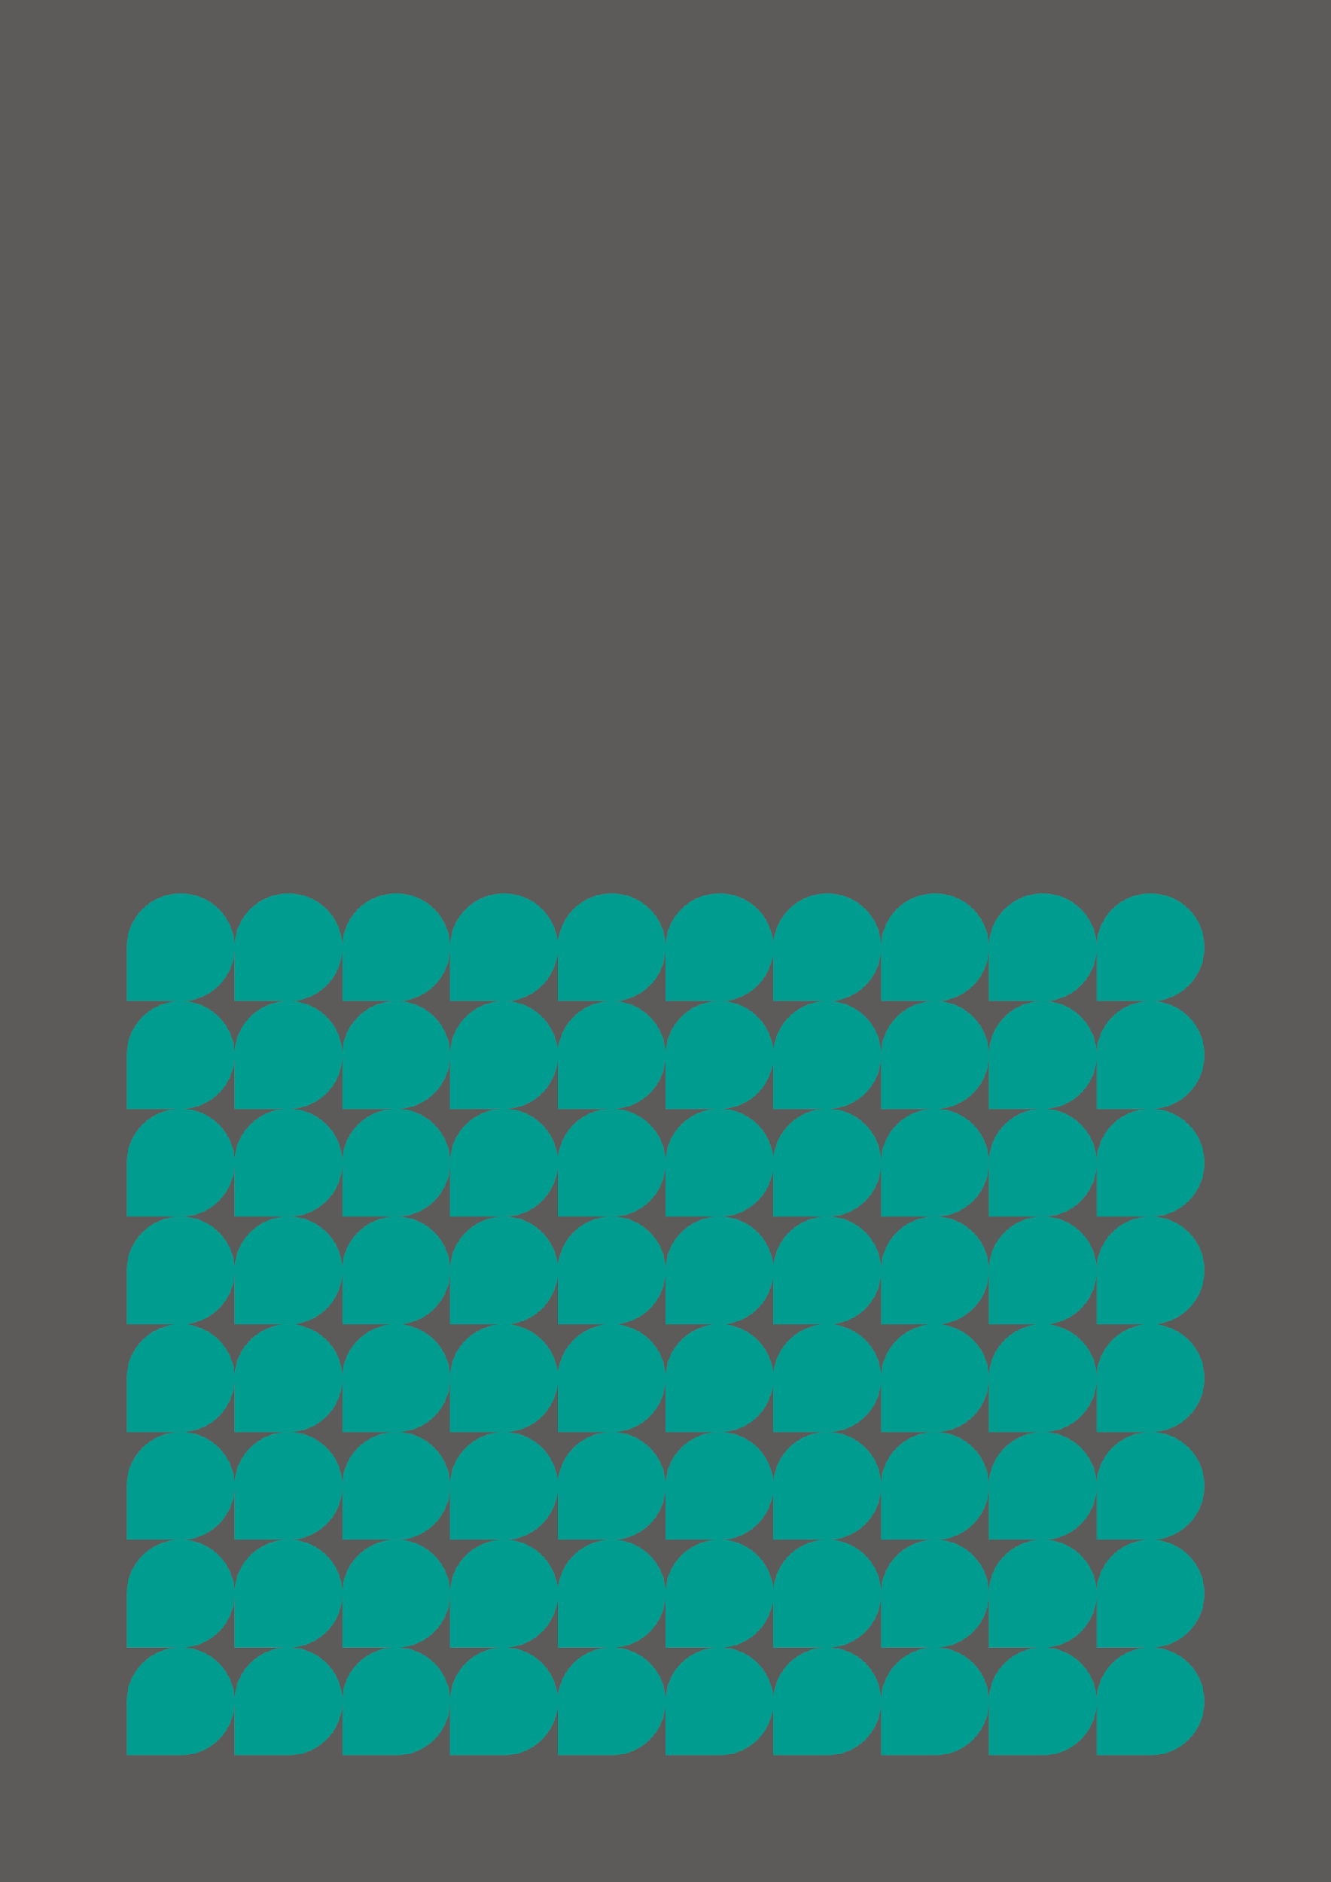
Greater Manchester Youth Combined Authority 2024-2026 Member Recruitment

Introduction
Greater Manchester Youth Combined Authority (GMYCA) was created in February 2018. It was the first of its kind in the country. The YCA gives young people in Greater Manchester the opportunity to have their voices heard and influence GMCA policy and decision making.
Its work comprises of:
- Advising the Mayor and GMCA on key issues and concerns of young people, and provide solutions
- Providing a critical voice and scrutinise the work of the Mayor and GMCA
- Undertaking specific pieces of work (for example, developing ‘Our Pass’ the free bus travel card for young people, and contributing to Greater Manchester’s annual Green Summits)
The YCA is an inclusive body, with diverse members who are able to represent a significant number of other young people. It is currently made up of 52 young people: 20 representatives from youth councils and 32 from other youth groups across the city-region – each organisation has two representatives.
Member organisations are appointed for a two-year term, and as the current term is drawing to a close, we are now seeking applications from youth organisations who are interested in being part of the Youth Combined Authority from April 2024 until March 2026.
More information about the Youth Combined Authority can be found at https://www.greatermanchester-ca.gov.uk/what-we-do/equalities/youth-combined-authority/

Mayor of Greater Manchester, Andy Burnham
“As Mayor I’m committed to investing in our young people and ensuring that Greater Manchester is one of the best places to grow up and get on. Greater Manchester Youth Combined Authority is a key part of that commitment as it guarantees young people the opportunity to advise, support and challenge the decisions being made in Greater Manchester.
Since 2018, GMYCA has made a real difference to lives in Greater Manchester. From helping to create Our Pass, shaping the Bee Network to advising our Violence Reduction Unit. Young people have truly made their voice heard.
Now is your opportunity to join and help shape the future of Greater Manchester.”

Chair of GMYCA- Maisha Lorgat
“Being part of the GMYCA leadership team has given me so many opportunities to get involved in other things. It’s been amazing, you learn and grow as a person. I’ve learnt so much over the last year and a half. I’ve gotten involved in a lot of things that I never would have seen myself getting involved in.
It is a great opportunity for young people to develop leadership skills. Skills that will take them far in life, and they can also be part of something bigger that will help their community grow and flourish.”

Current membership

- The Proud Trust
- Water Adventure Centre (WAC)
- Greater Manchester Youth Network (GMYN)
- Be The Change Youth Project CIC
- Manchester Youth Zone
- Rochdale Connections Trust
- KYSO Project CIC
- Groundwork Cheshire, Lancashire & Merseyside
- One Manchester
- HideOut Youth Zone
- Greater Manchester Army Cadet Force
- Caribbean & African Health Network (CAHN)
- Youth Leads UK
- Greater Manchester Fire and Rescue Service
- Blossom Foundation
- Bury Youth Council
- Rochdale Youth Council
- Oldham Youth Council
- Wigan Youth Council
- Manchester Youth Council
- Tameside Youth Council
- Salford Youth Council
- Stockport Youth Council
- Trafford Youth Council
- Bolton Youth Council

Expectations of member organisations
Organisations must agree to:

1) Put forward two young people to be part of the Youth Combined Authority (YCA). Members should be aged 11-18, or up to 25 for those with additional needs. Members should be as consistent as possible, although deputies may attend in their absence.
2) Let the GMCA know as soon as members leave, and ensure they are replaced within two meetings.
3) Support both their members to attend YCA meetings for their full term. Meetings are held monthly, on the second Thursday of every month, except May and August when there are no meetings at all. (Please note, organisations whose members do not attend three meetings in a row, or at least three in a six-month period may be asked to stand down.)
4) Support both their members to attend YCA Development Days twice a year.
5) Assign a member of staff to be the lead contact for the GMCA.
6) Attend youth worker meetings three times a year to provide feedback, help shape the future development of the YCA and share best practice.
7) Help their members develop their personal networks so other young people – inside and outside their own organisation – are aware of YCA activities and have the opportunity to input.
8) Contribute to progress reports, evaluations, and other research reports as requested by the GMCA.
9) Support and cooperate with the delivery organisation for the YCA.
10) Be advocates for the YCA, and promote its work positively through their networks.
11) Understand that their participation in the YCA is voluntary and they will not receive funding from the GMCA (although reasonable travel expenses to meetings are paid).
Organisations may agree to:
12) Put forward additional young people to be part of the YCA’s working groups, and support them to attend and be active members.
13) Contribute additional support in kind, for example venues and equipment.

For young people, during your term of office it is your responsibility to:
- Identify, discuss and debate issues of concern to young people. You could do this by getting involved in GMYCA consultation activities, questionnaires, hold meetings and focus groups with young people, reply to letters and emails, take part in meetings and respond to plans and consultations.
- Act on those issues and identify how to make a change at a local level, or resist unwanted change. You must also follow up decisions or actions. You could do this by lobbying, meeting decision makers, organising consultations and campaigning.
- Develop and increase the representation of young people to their benefit. You could do this by supporting your school councils, local youth forums etc., working with the GMCA press team to promote a positive image of young people in the media.

Application process
Who can apply to be a member organisation?
- Organisations that work with young people aged between 11 and 19 (or up to 25 for those with additional needs)
- Who represent a diverse range of identities and backgrounds
- Who work within Greater Manchester
How long is the term and commitment expected from organisations?
- The term is two years, from April 2024 to March 2026
- Meetings are held monthly on the second Thursday of each month
How can my youth organisation apply?
- Interested organisations should complete the application form using this link https://forms.office.com/e/e6jvRPYNia by 5pm on Friday 19th January 2024.
If you have any other questions please email h.mcmullan@youthfocusnw.org.uk
